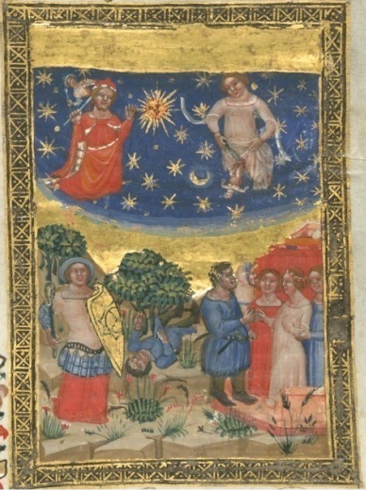
Figure 1: Birth of Pallas and Vulcan (top), fall of Vulcan and marriage of Vulcan with Venus (bottom), in Gotha, Forschungs bibliotheck Ms. I.98, f. 21r, Bologna c. 1350 (Berchorius 2021, vol. 1, Fig. 27).

Figure 2: Birth of Pallas and Vulcan (left), marriage of Vulcan with Venus (right) in Bergamo, Biblioteca Civica Angelo Mai Cassaf. 3.4, f. 41v, Padova c. 1390.

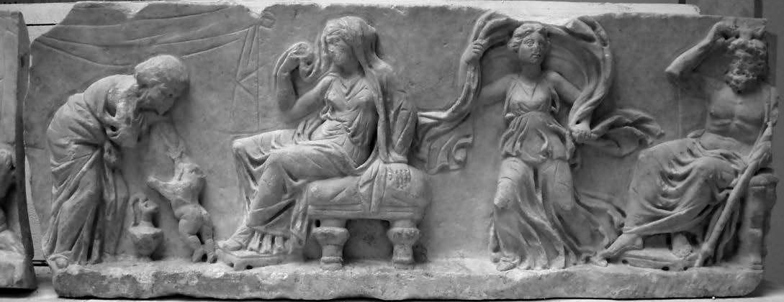
Figure 3: Frieze Ostia-Berlin (inv. 148), mid-2nd century CE, marble, Museo Ostiense (Zevi, Micheli 2012, Fig. 1).

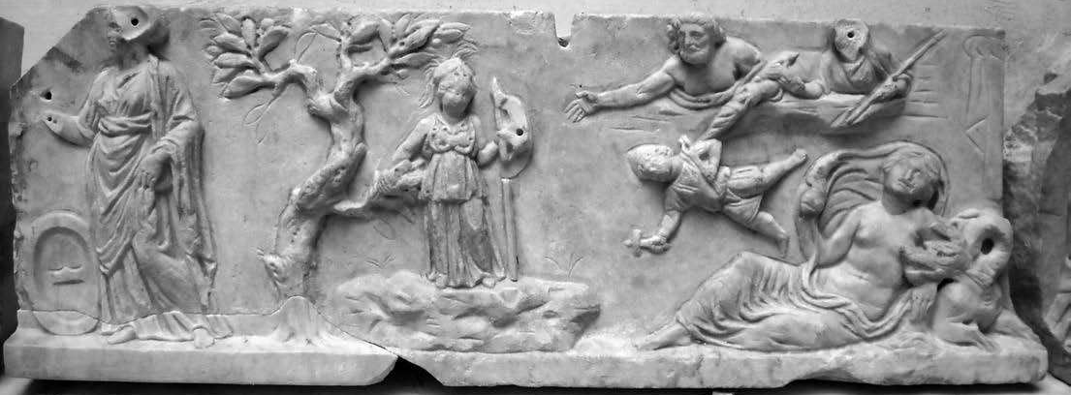
Fig. 4: Frieze Ostia-Berlin (inv. n. 912), mid-2nd century CE, marble, Staatliche Museen Berlin (Zevi, Micheli 2012, Fig. 3).

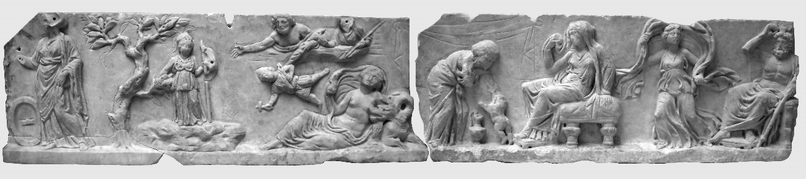
Fig. 5: Frieze Ostia-Berlin (inv. nn. 912 and 148), mid-2nd century CE, marble, Museo Ostiense (Zevi, Micheli 2012, Fig. 9).

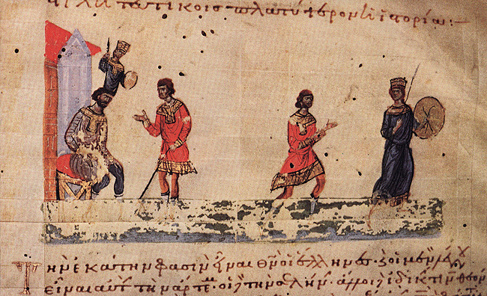
Fig. 6: Birth of Pallas from the head of Jupiter (left), Vulcan's amorous pursuit of Pallas (right), in Jerusalem, Patriarchal Library Cod. Taphou 14, f. 312, 11th century (The Index of Medieval Art).

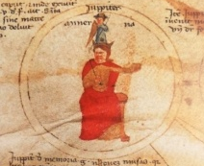
Fig. 7: Master of the Genealogiae deorum Add. 5729, Birth of Minerva from the head of Jupiter, in London, British Library Cod. Add. 57529, fol. 4v, c. 1374 (Berchorius ed. 2021, vol. 1, Fig. 272).

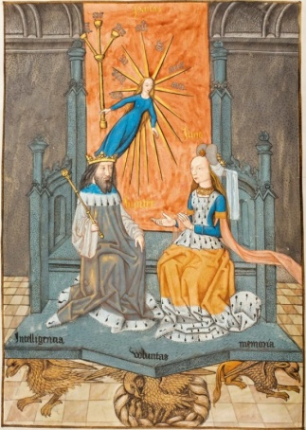
Fig. 8: Flemish Master Raphael de Mercatellis, Birth of Pallas/Sapientia from the head of Jupiter in Ghent, St Bavo Ms 16A, f. 8, c. 1508 (The Warburg Institute Iconographic Database).

