Appendix

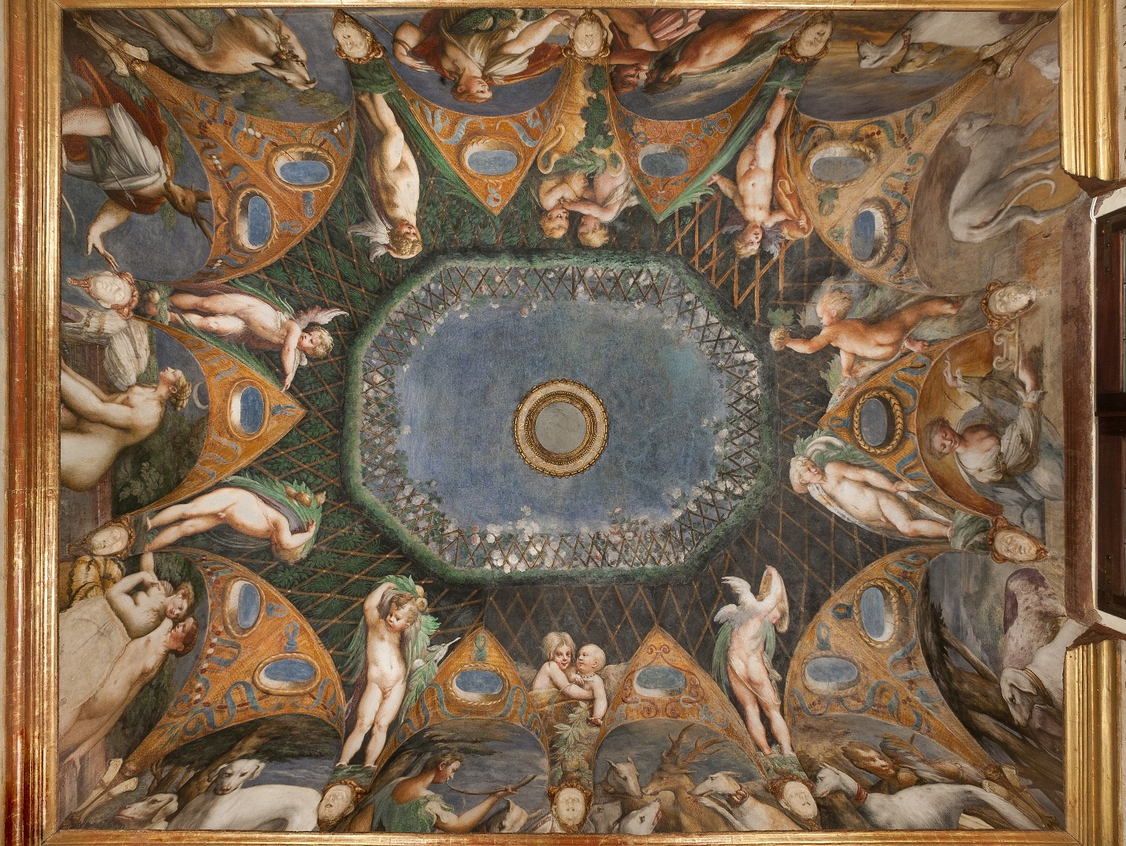

Fig. 1. Parmigianino, Diana and Actaeon, 1523–1524. Rocca Sanvitale, Fontanellato. Photograph provided by Art Resource, New York.
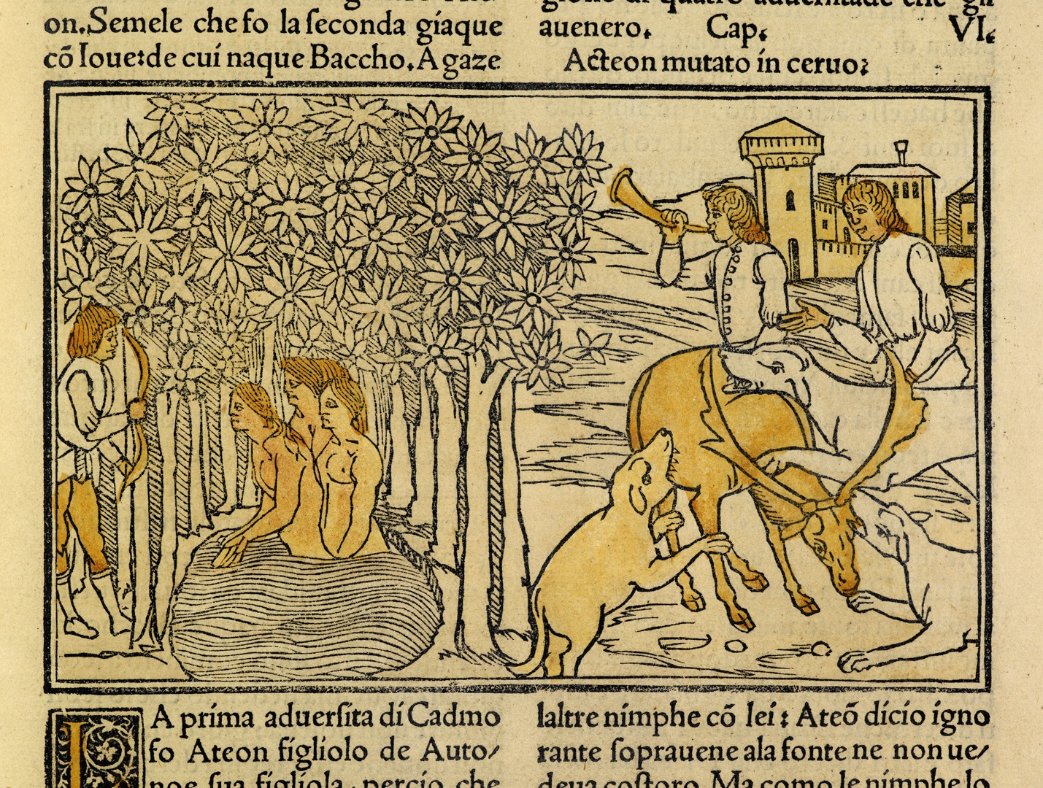

Fig. 2. Italian printmaker, Diana and Actaeon, ca. 1497. British Library, London. Reproduced with permission from the British Library.

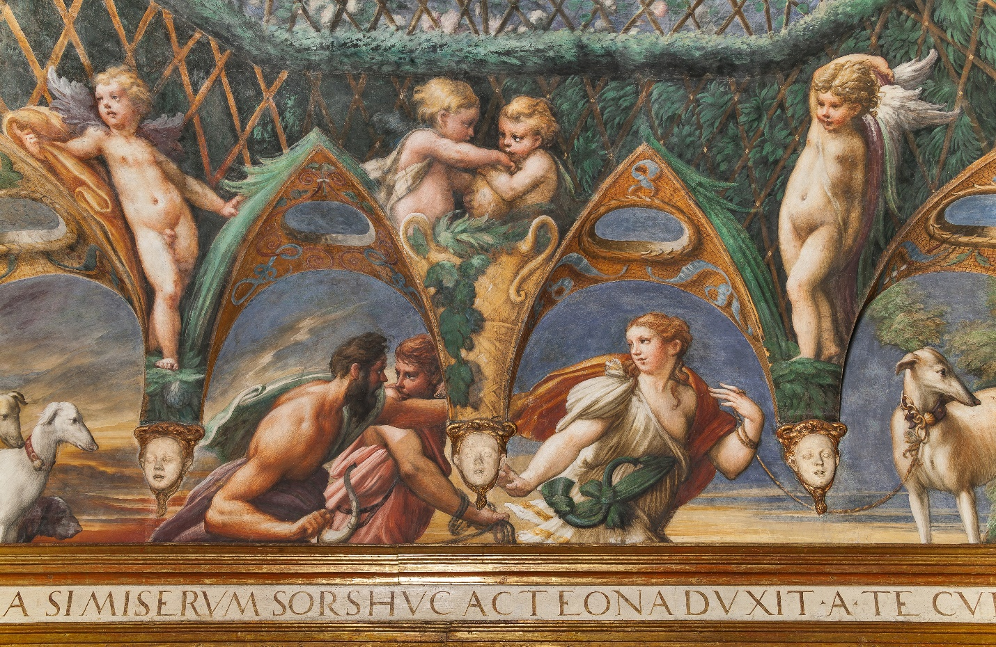

Fig. 3. Parmigianino, detail of Diana and Actaeon (above north wall), 1523–1524. Rocca Sanvitale, Fontanellato. Photograph provided by Art Resource, New York.
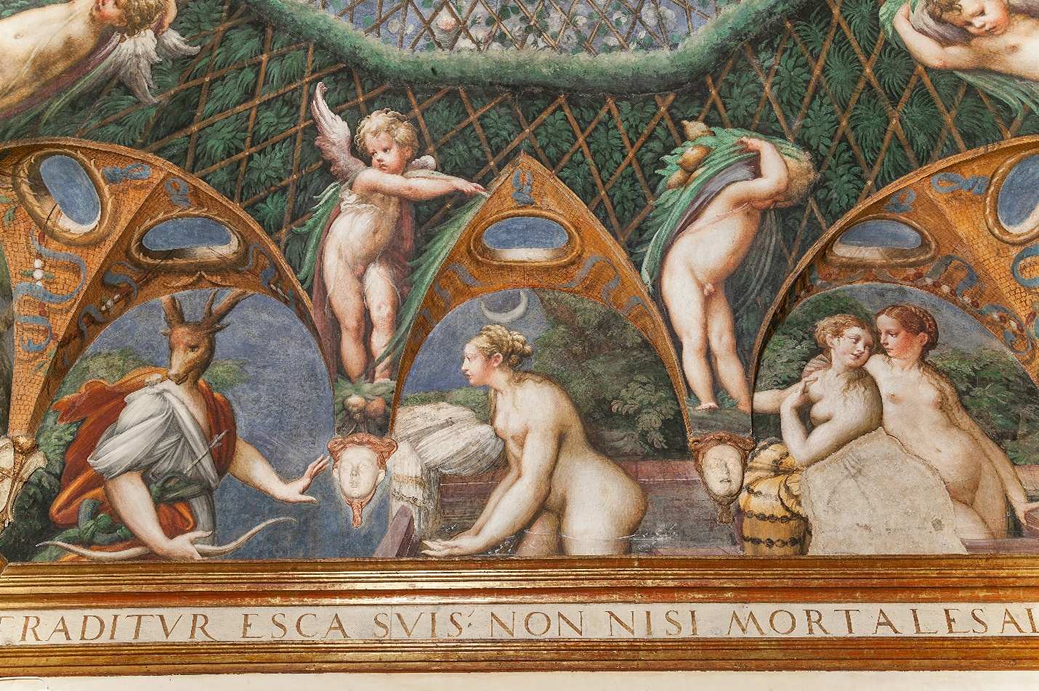

Fig. 4. Parmigianino, detail of Diana and Actaeon (above east wall), 1523–1524. Rocca Sanvitale, Fontanellato. Photograph provided by Art Resource, New York.
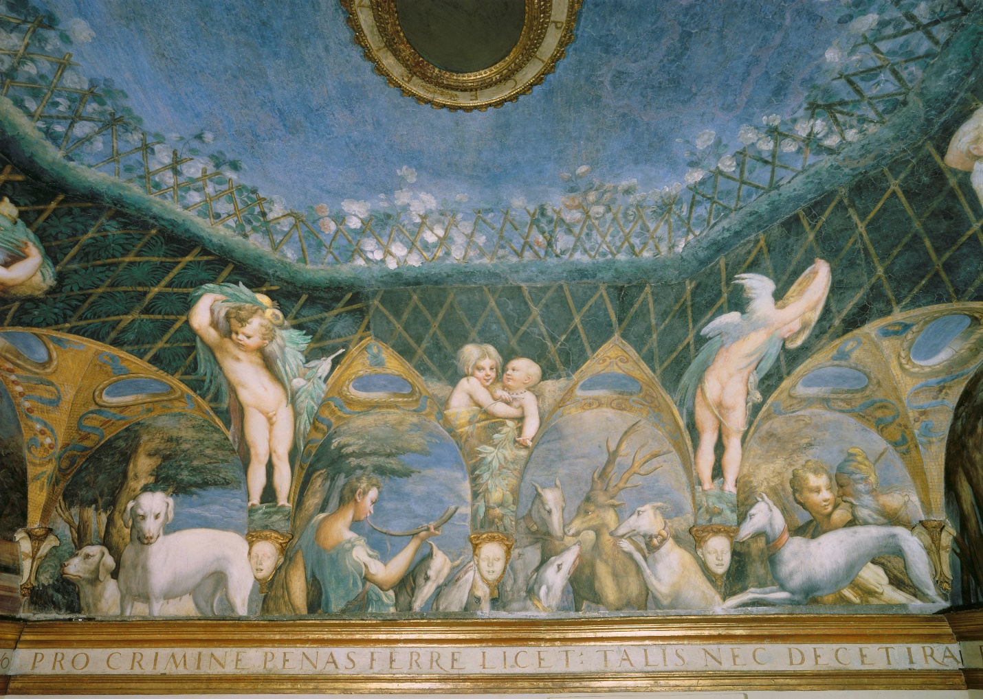

Fig. 5. Parmigianino, detail of Diana and Actaeon (above south wall), 1523–1524. Rocca Sanvitale, Fontanellato. Photograph provided by Art Resource, New York.
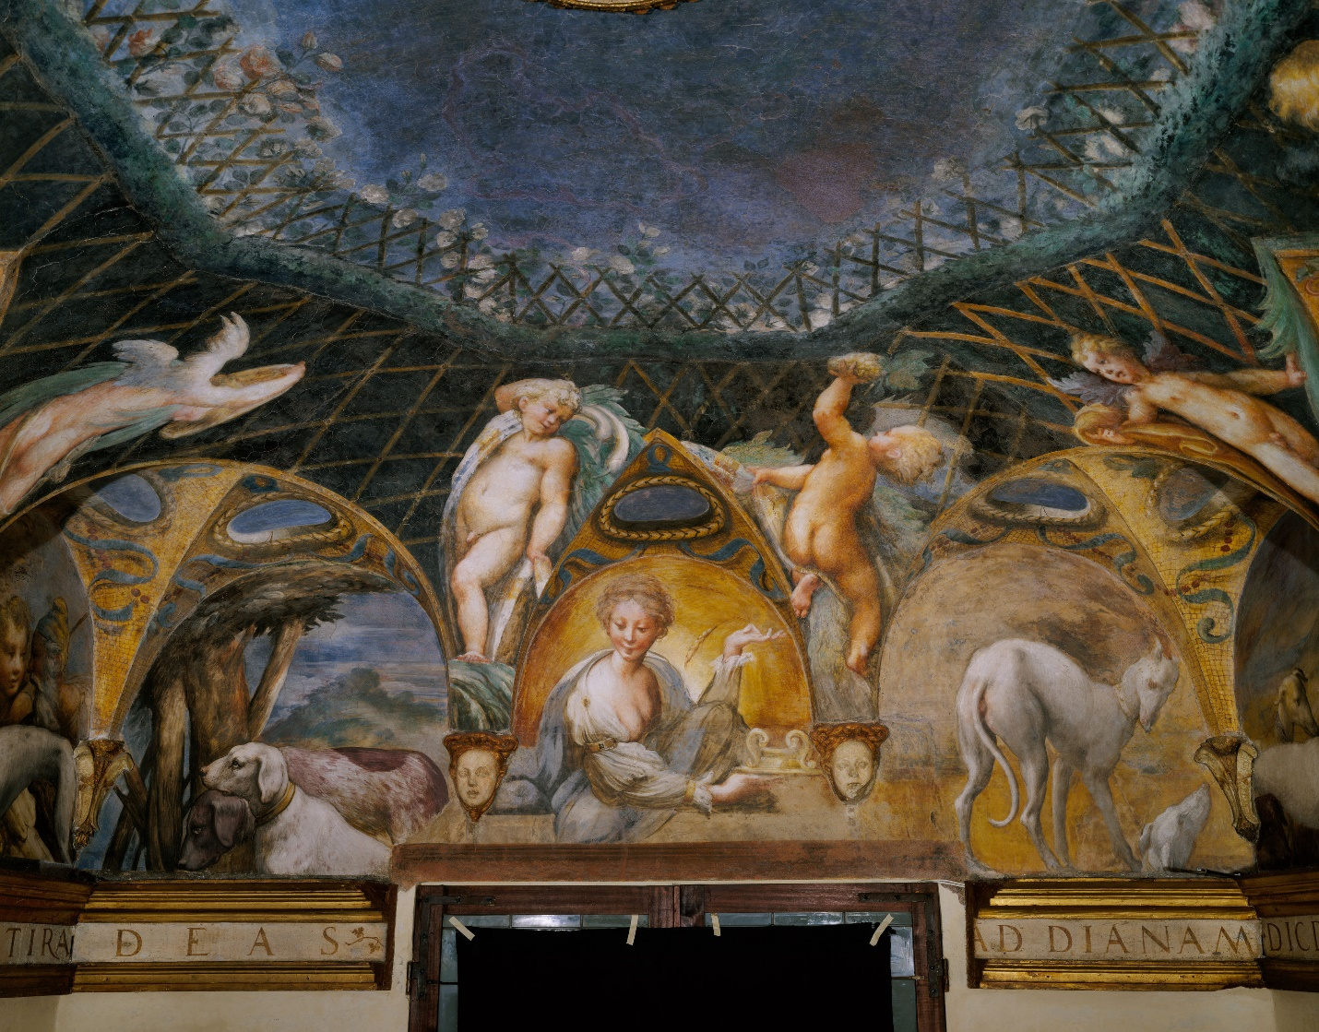

Fig. 6. Parmigianino, detail of Diana and Actaeon (above west wall), 1523–1524. Rocca Sanvitale, Fontanellato. Photograph provided by Art Resource, New York.
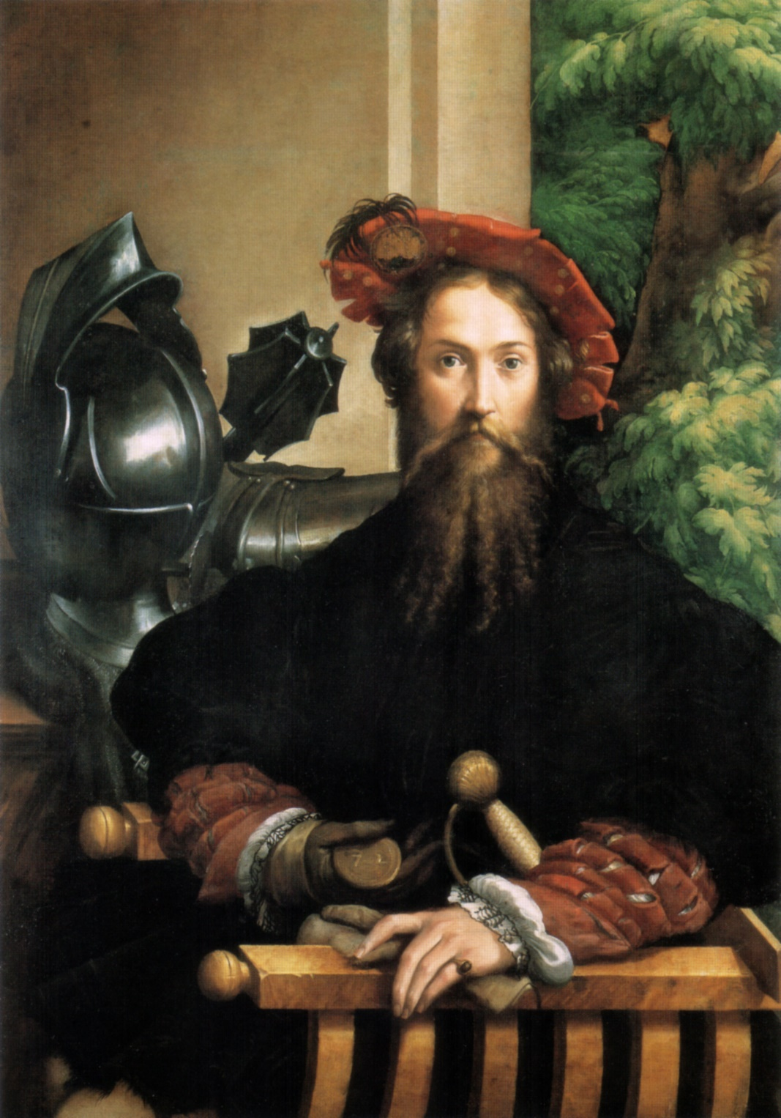

Fig. 7. Parmigianino, Portrait of Giangaleazzo Sanvitale, ca. 1524. National Museum of Capodimonte, Naples. Image in the Public Domain, from Wikimedia Commons.
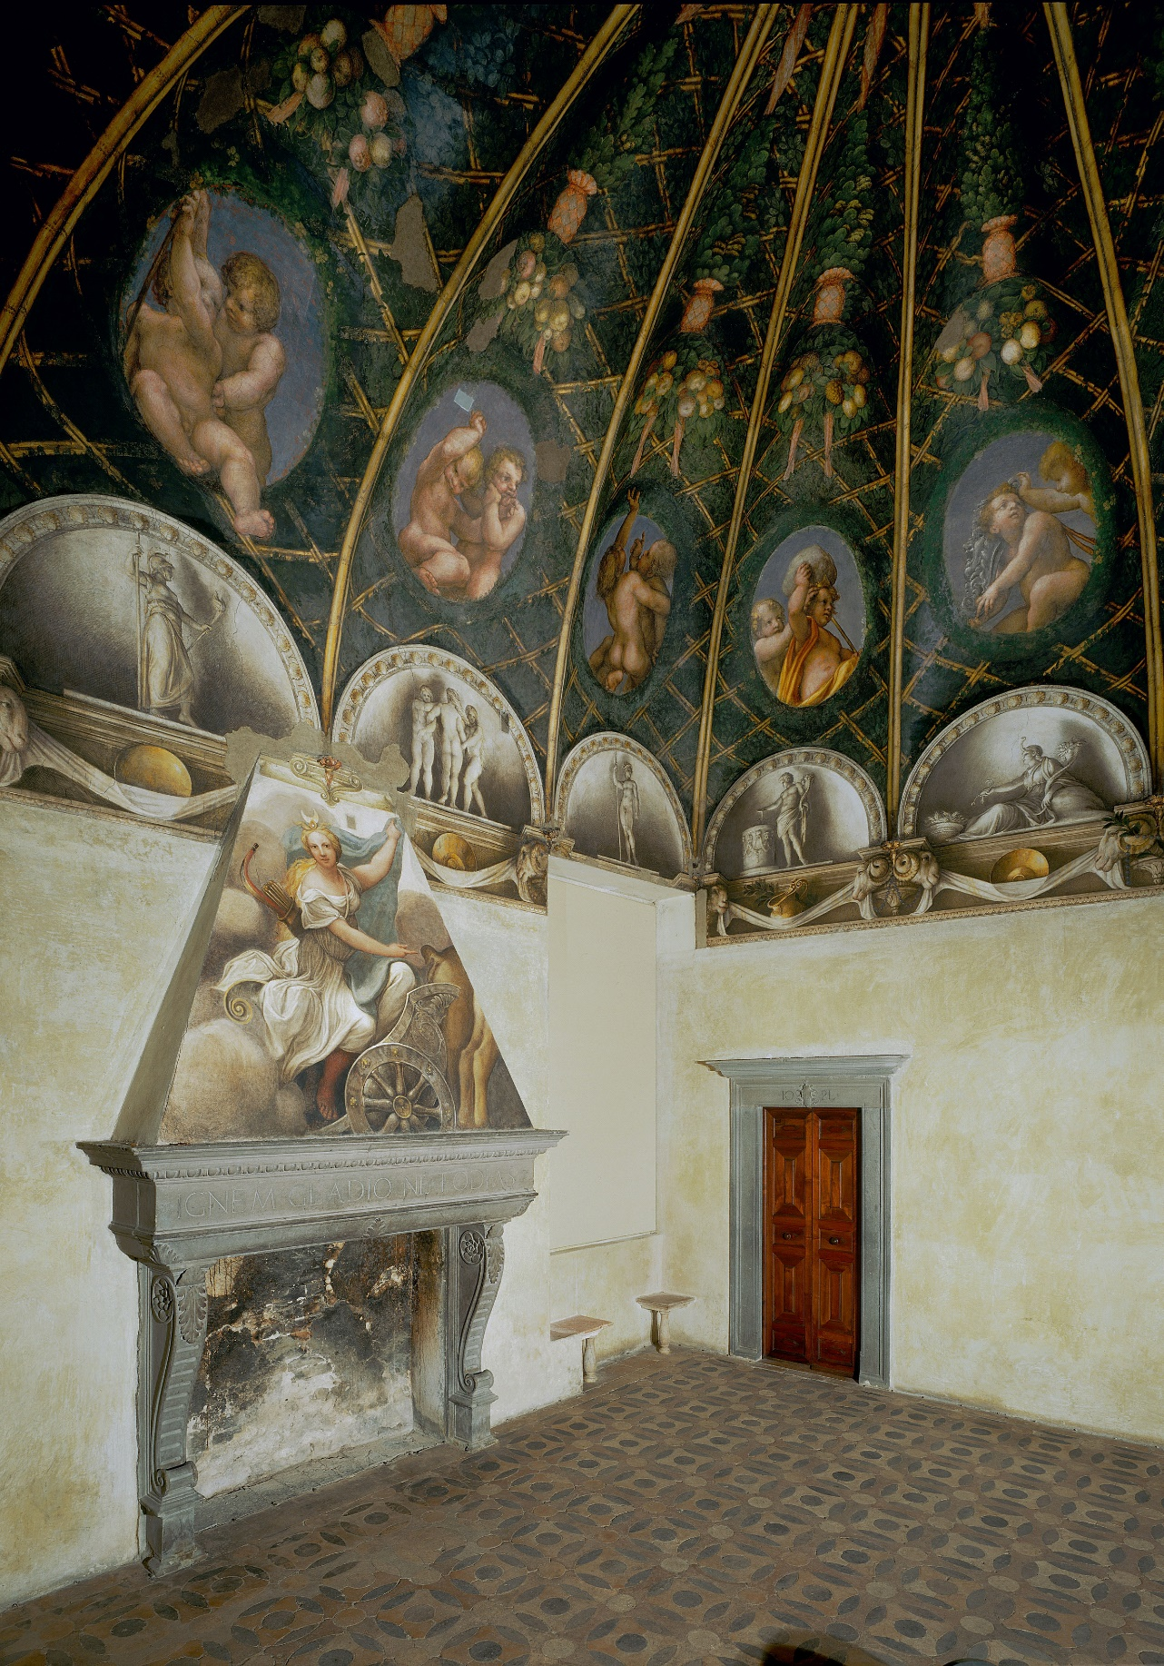

Fig. 8. Correggio, Camera di San Paolo, 1519. San Paolo, Parma. Photograph provided by Art Resource, New York.

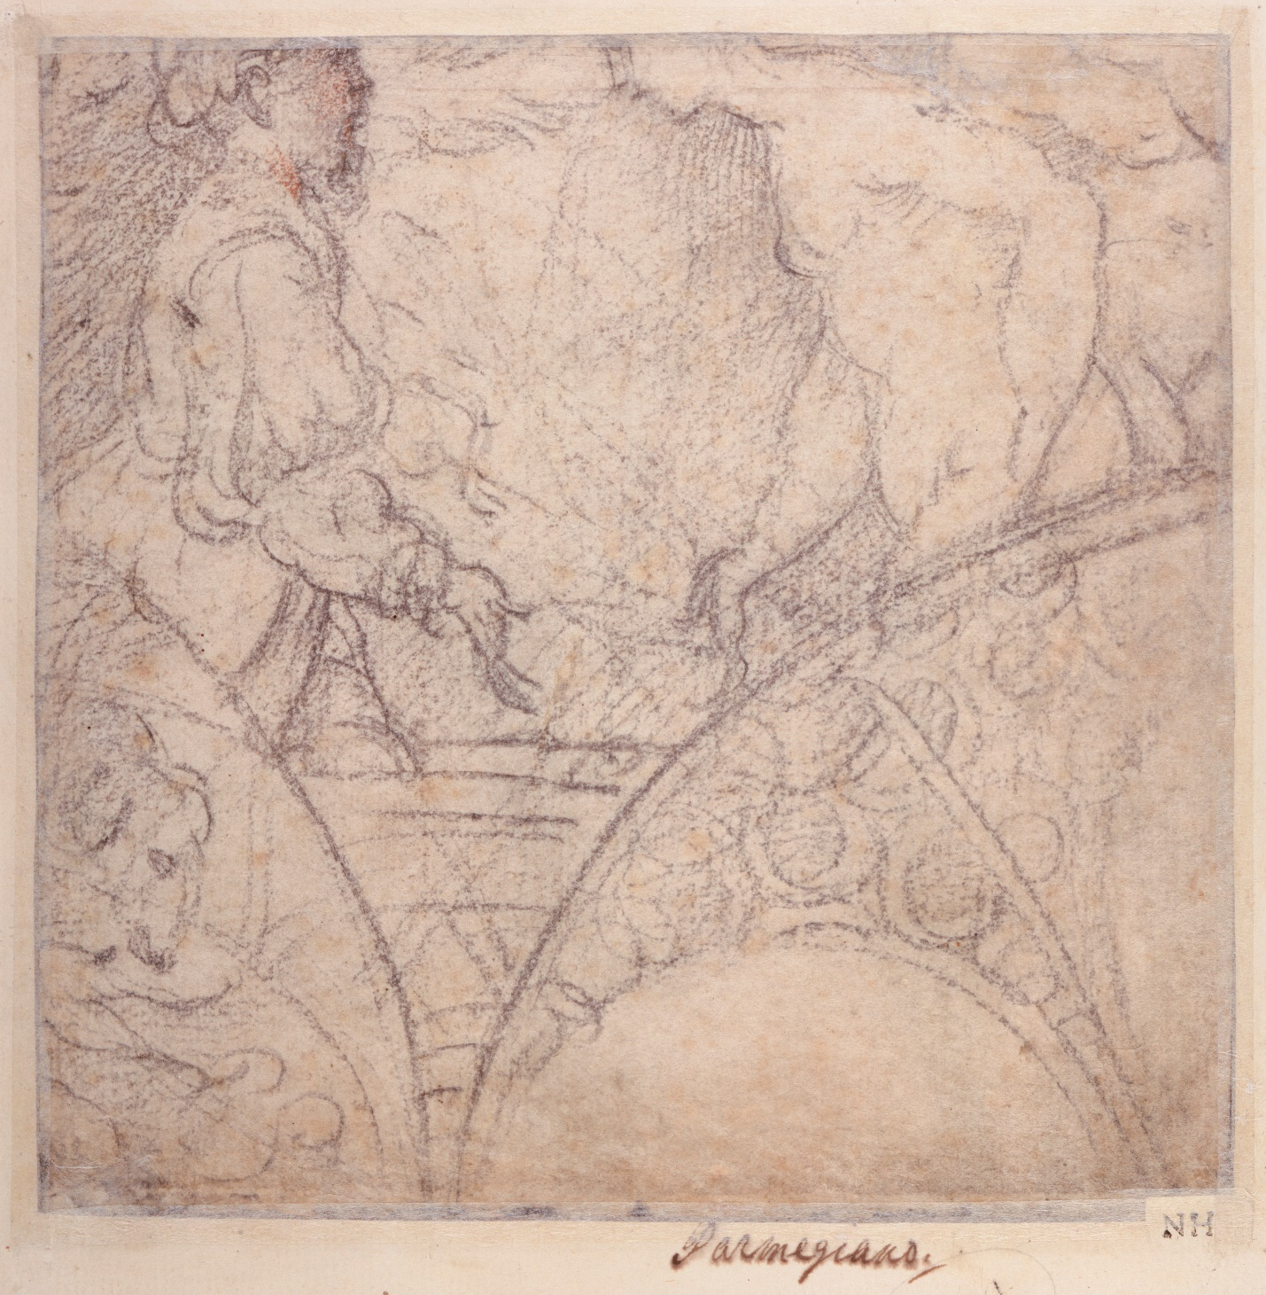

Fig. 9. Parmigianino, Diana and Actaeon, ca. 1523–1524. Morgan Library, New York. Photograph provided by Art Resource, New York.
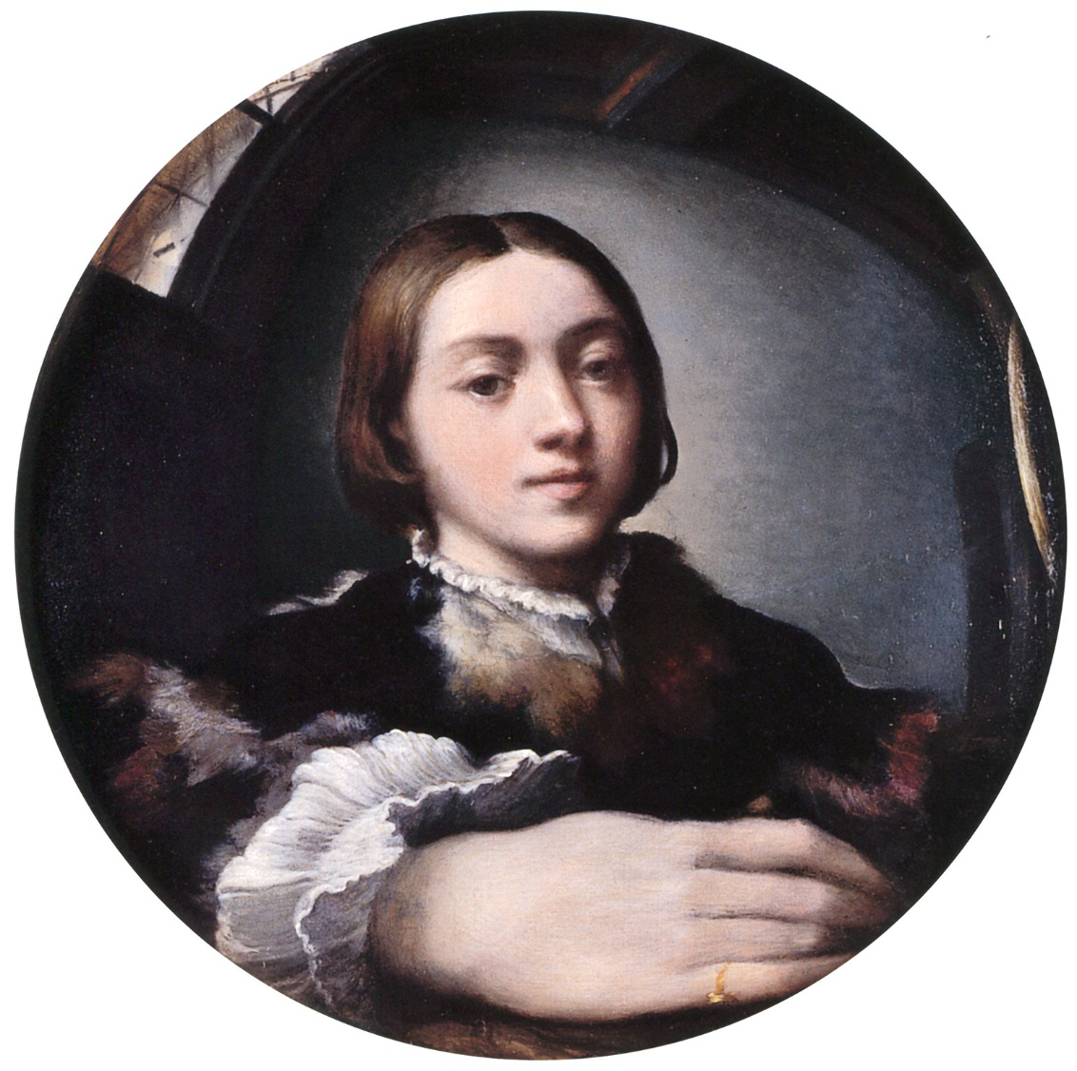

Fig. 10.Parmigianino, Self-Portrait in a Convex Mirror, ca. 1524. Kunsthistorisches Museum, Vienna. Image in the Public Domain, from Wikimedia Commons.

