Appendix

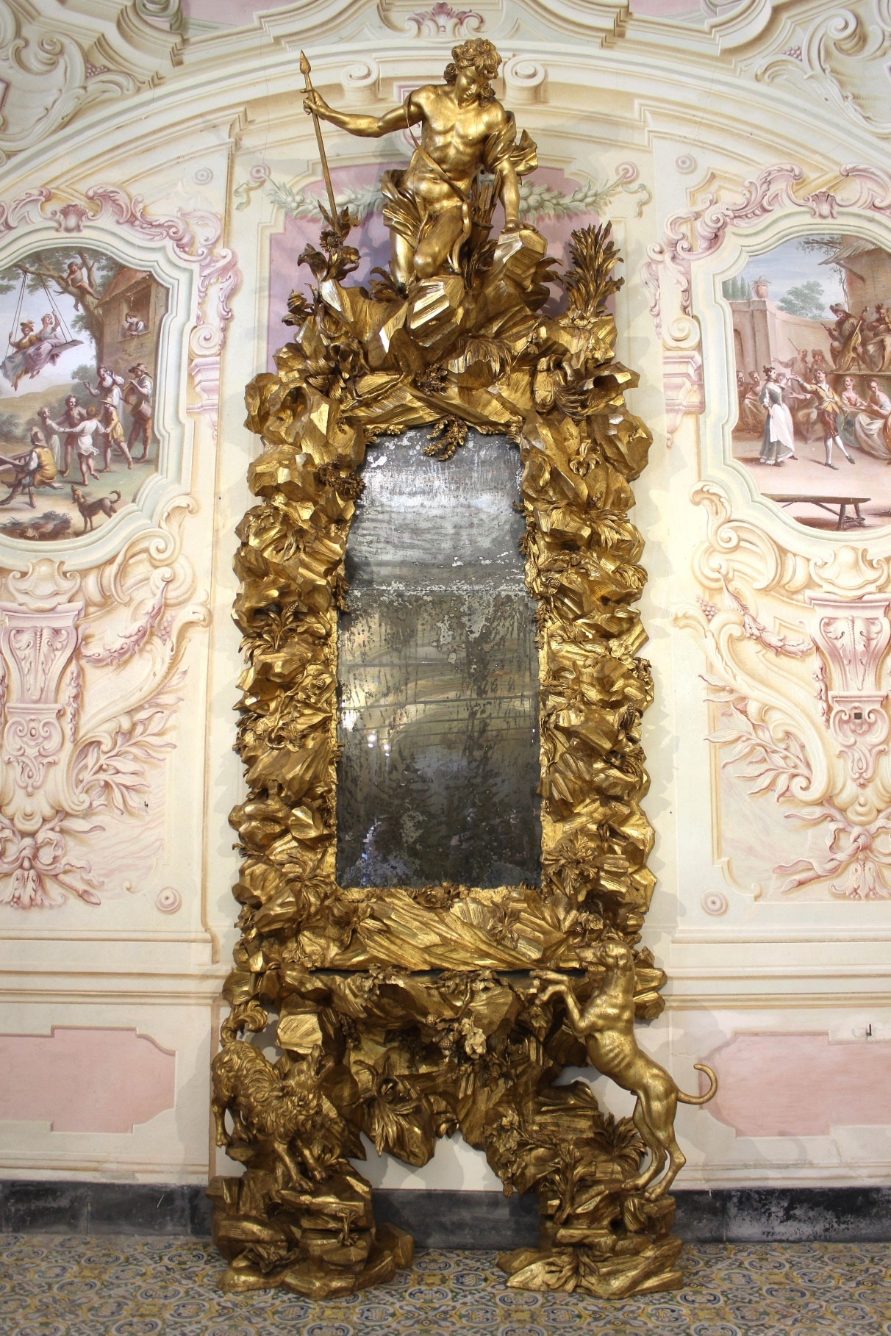

Fig. 1 Filippo Parodi, Mirror with the myth of Narcissus, 17th century, wood with golden colour, 450 x 170 x 70 cm (Photo R. Dobslaw 2023)
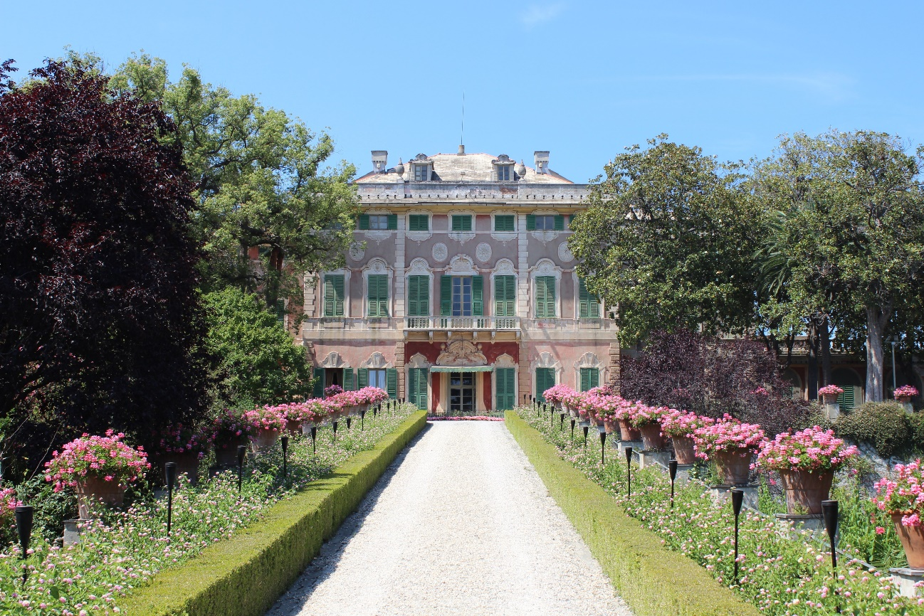

Fig. 2 Villa Durazzo Faraggiana di Albissola Marina, 18th century (Photo R. Dobslaw 2023)

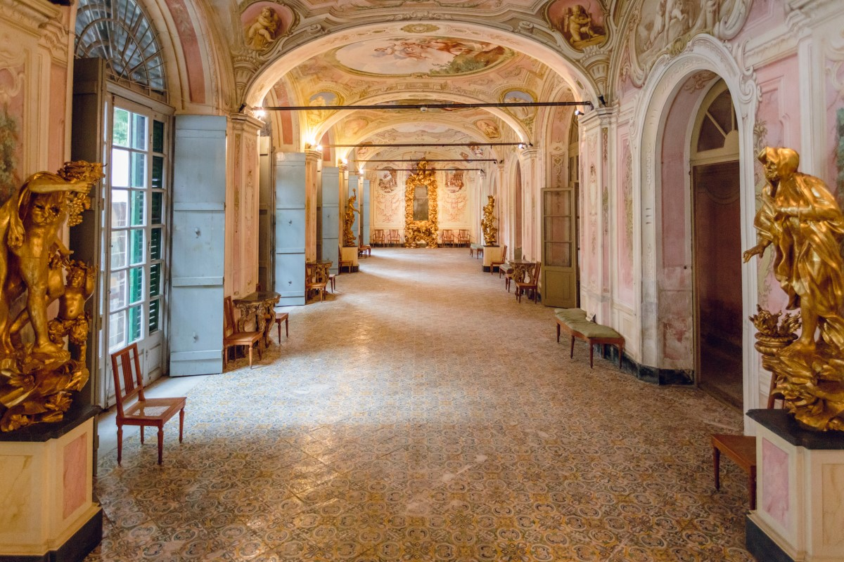

Fig. 3 Galleria delle Stagioni, mid-18th century (Photo Museo Villa Faraggiana)

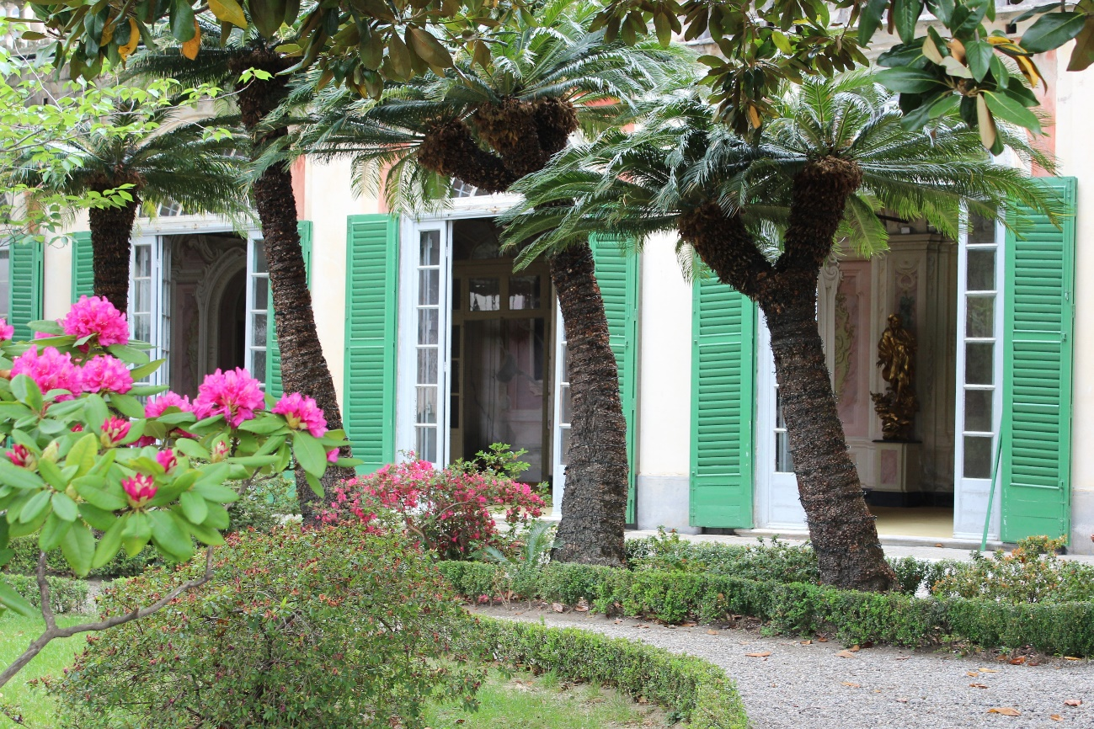

Fig. 4 Garden of the Villa with the Galleria delle Stagioni (Photo R. Dobslaw 2022)

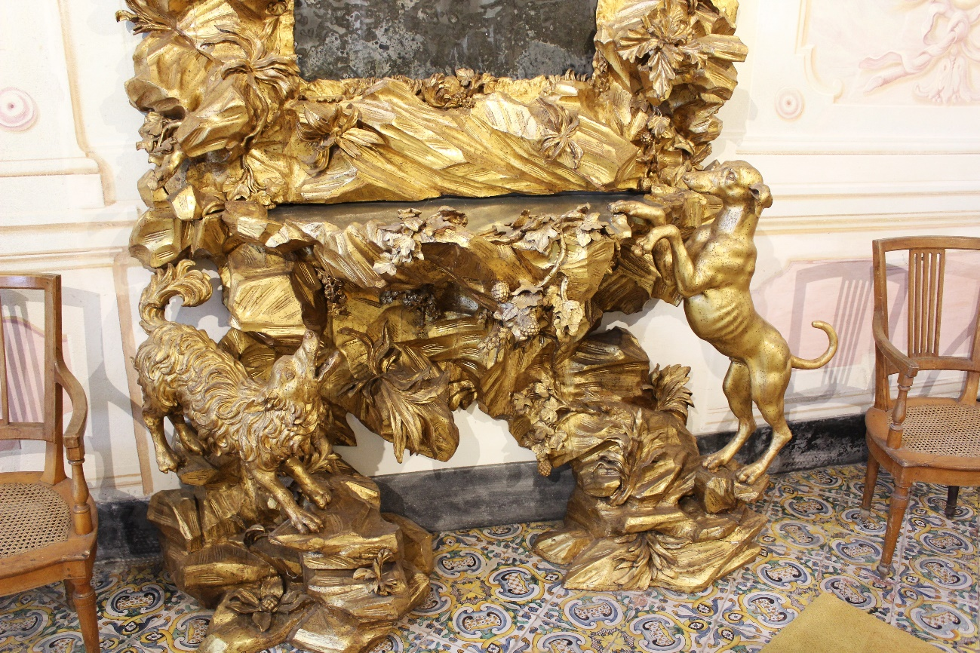

Fig. 5 Filippo Parodi, Mirror with the myth of Narcissus (Detail) (Photo R. Dobslaw 2022)

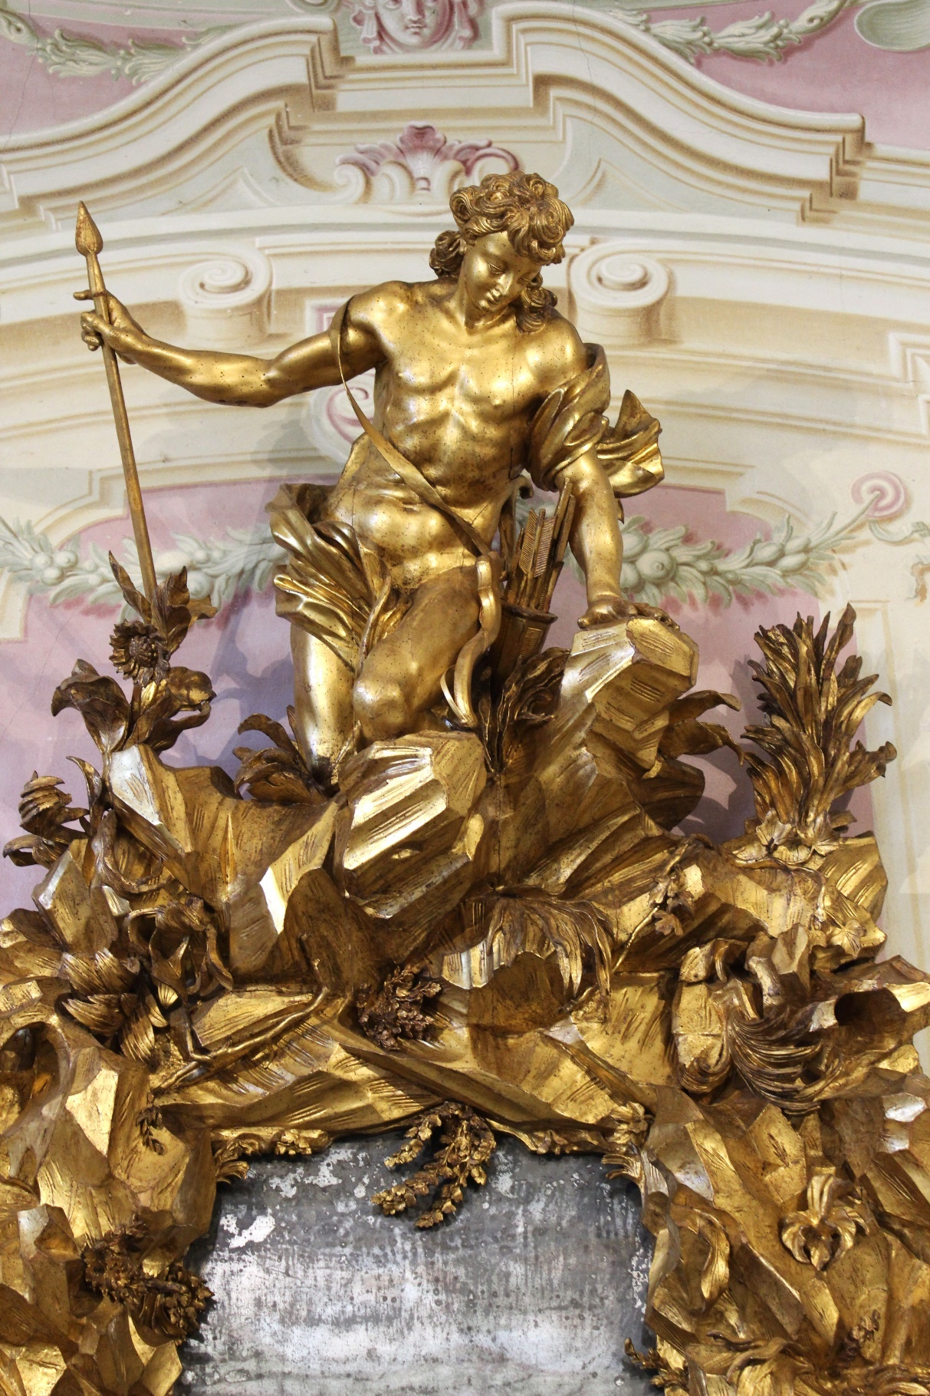

Fig. 6 Filippo Parodi, Mirror with the myth of Narcissus (Detail) (Photo R. Dobslaw 2023)
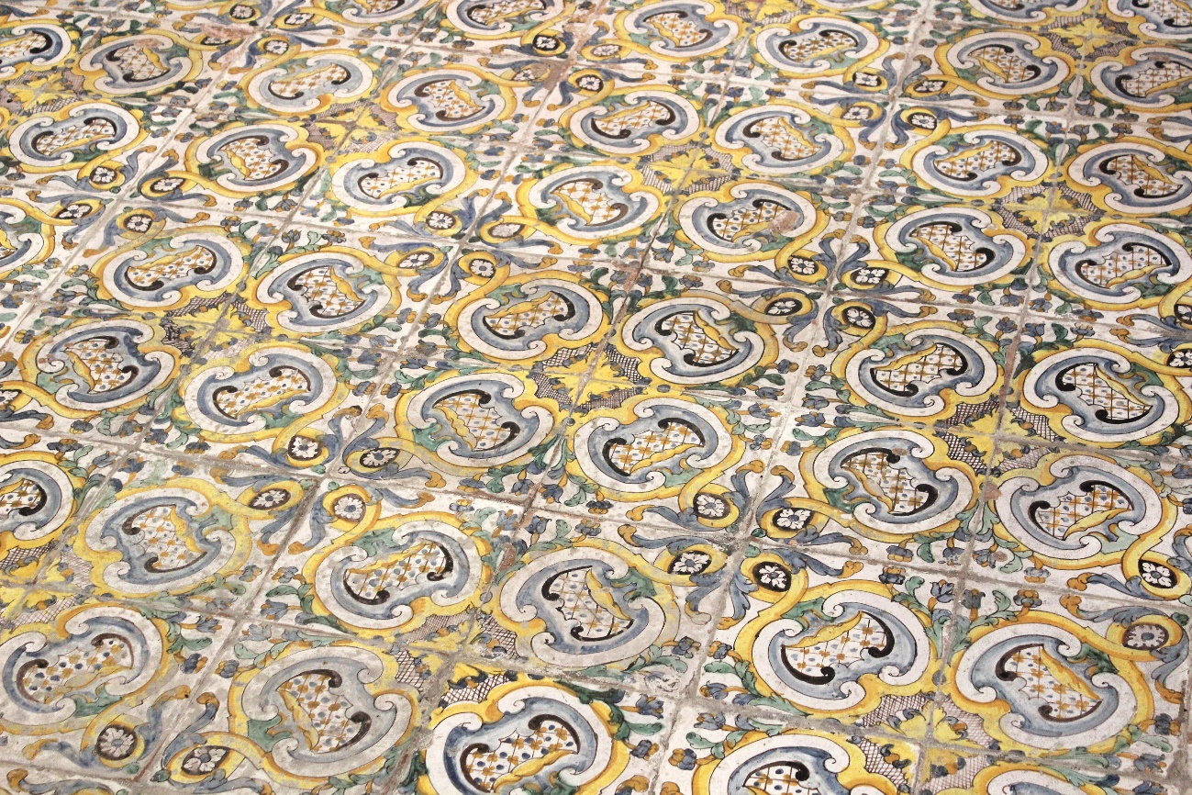

Fig. 7 Ligurian manufacture, Tiles on the floor of the Galleria delle Stagioni, 18th century, polychrome maiolica (Photo R. Dobslaw 2023)

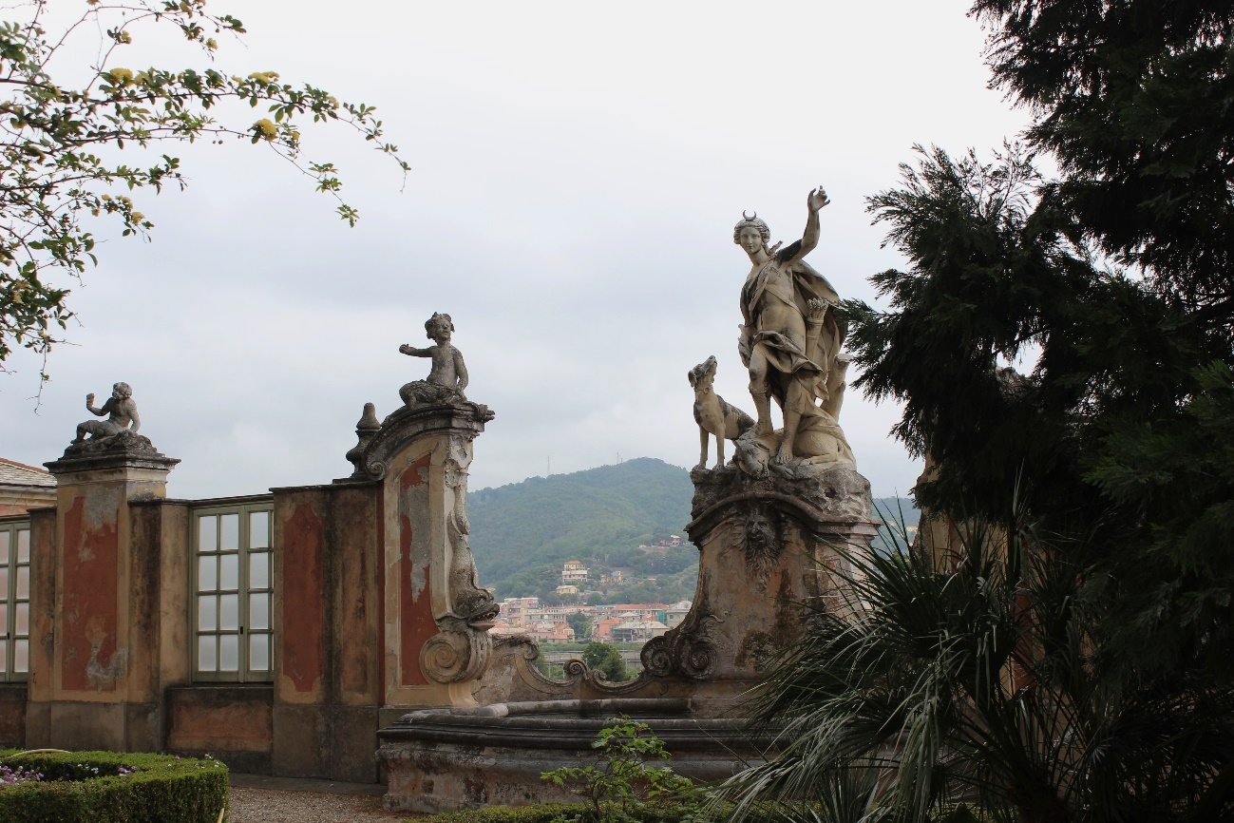

Fig. 8 Unknown Ligurian sculptor, Fountain with the sculpture of Diana, 2nd half of the 18th century, marble and stucco, garden of the Villa Durazzo Faraggiana di Albissola Marina (Photo R. Dobslaw 2022)

