Figures

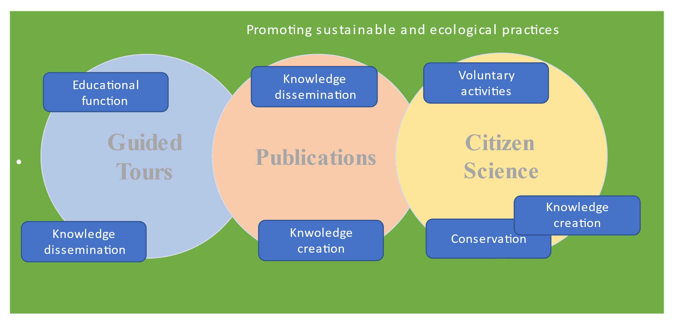
Fig.1 NHM activities that generate social value and their function (Source: Authors’ elaboration)

