Fig. 1. The corporate heritage marketing process. (Source: our elaboration from Riviezzo et al. 2021).

(p.4)
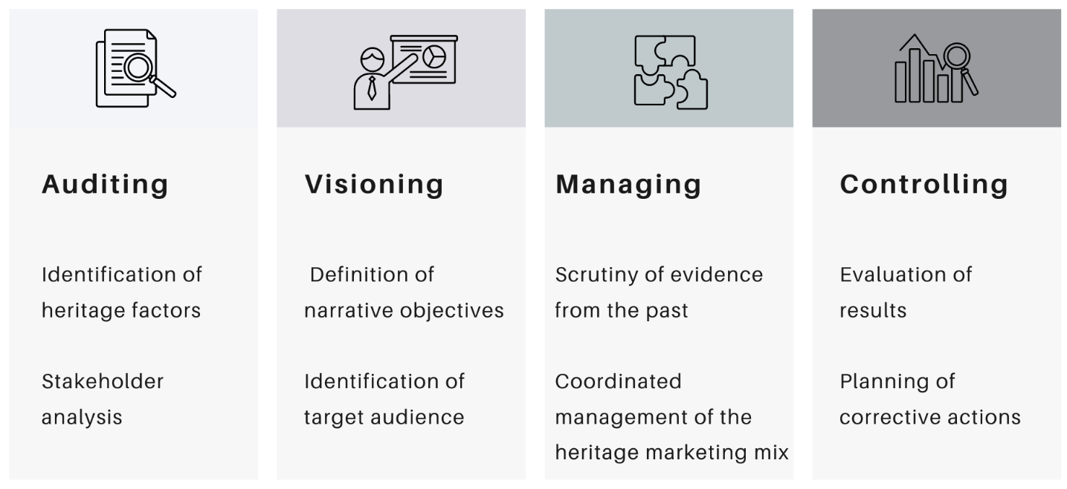

Fig. 2. Differences between multichannel, cross-channel and omnichannel marketing (Source: our elaboration from Berman, Thelen 2018).
(p. 5)

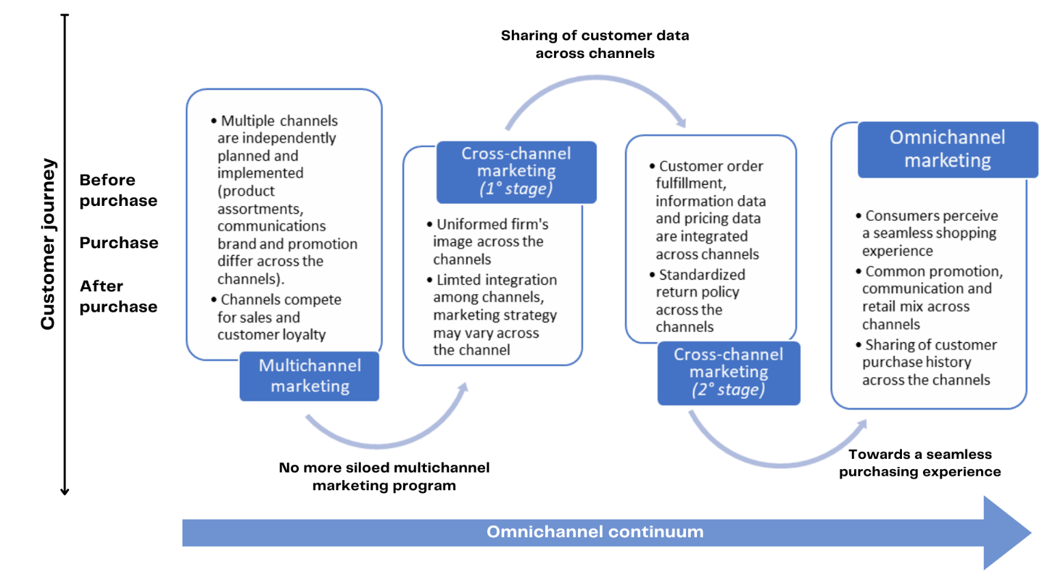

Fig. 3. The first analytical framework developed (Source: our elaboration from Riviezzo et al. 2021).
(p.9)
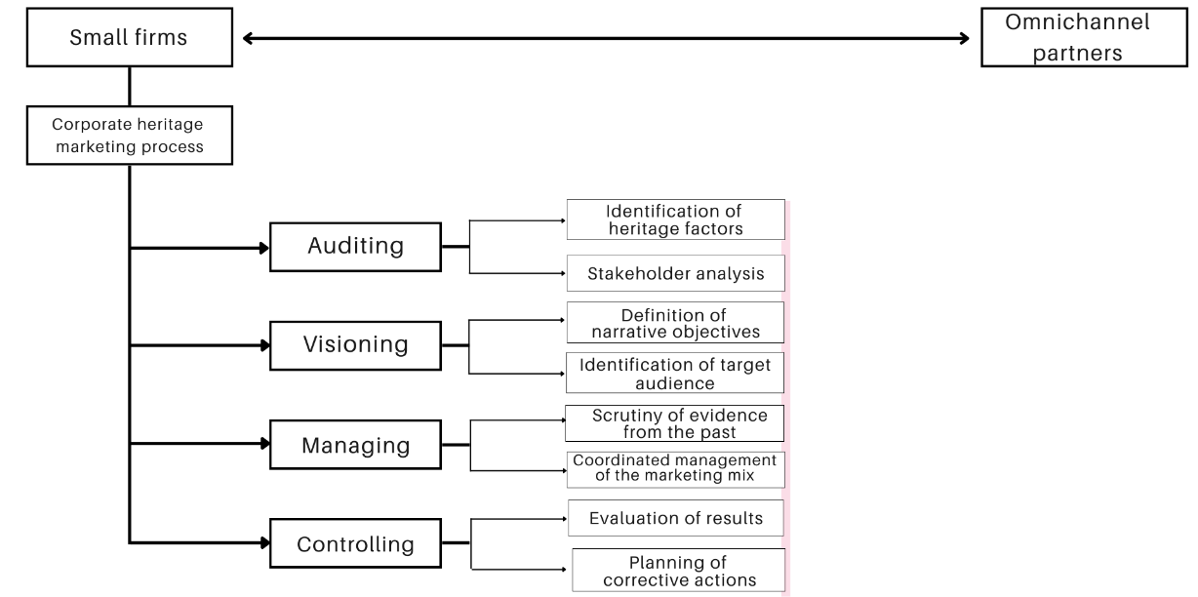

Fig. 4. A new analytical framework the study develops based on new theoretical concepts (Source: our elaboration from Riviezzo et al. 2021).
(p.9)

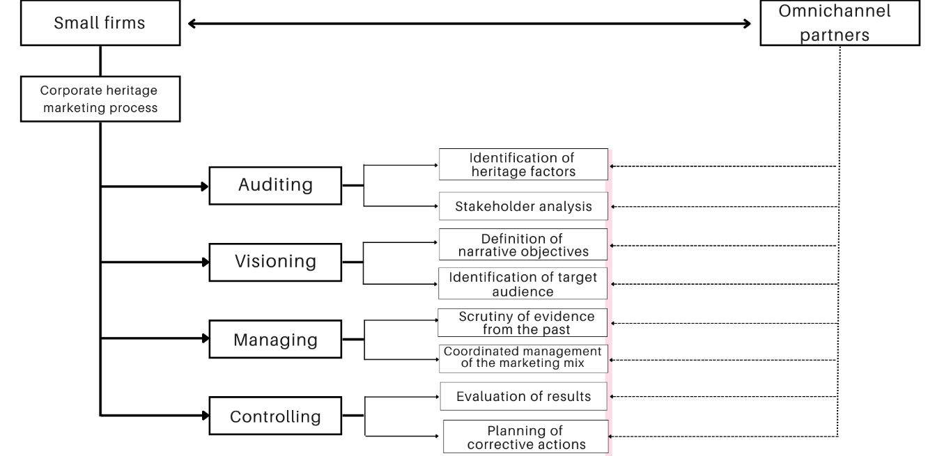

Fig. 5. CHM mix adopted by the small winery. (Source: our elaboration from Garofano et al. 2020).
(p.11)

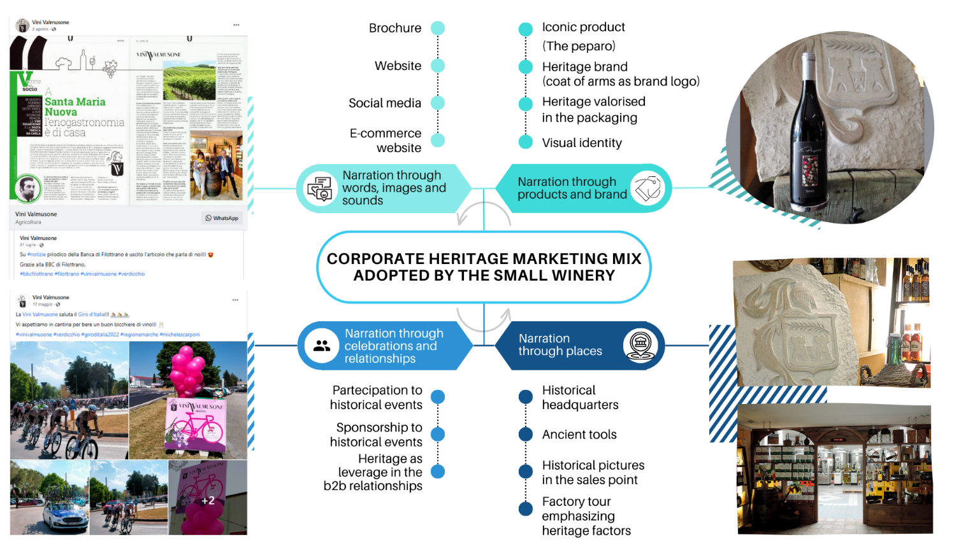
Fig. 6. The Peparo bottle of wine presentation in the partner’s e-commerce platform.
(p.13)

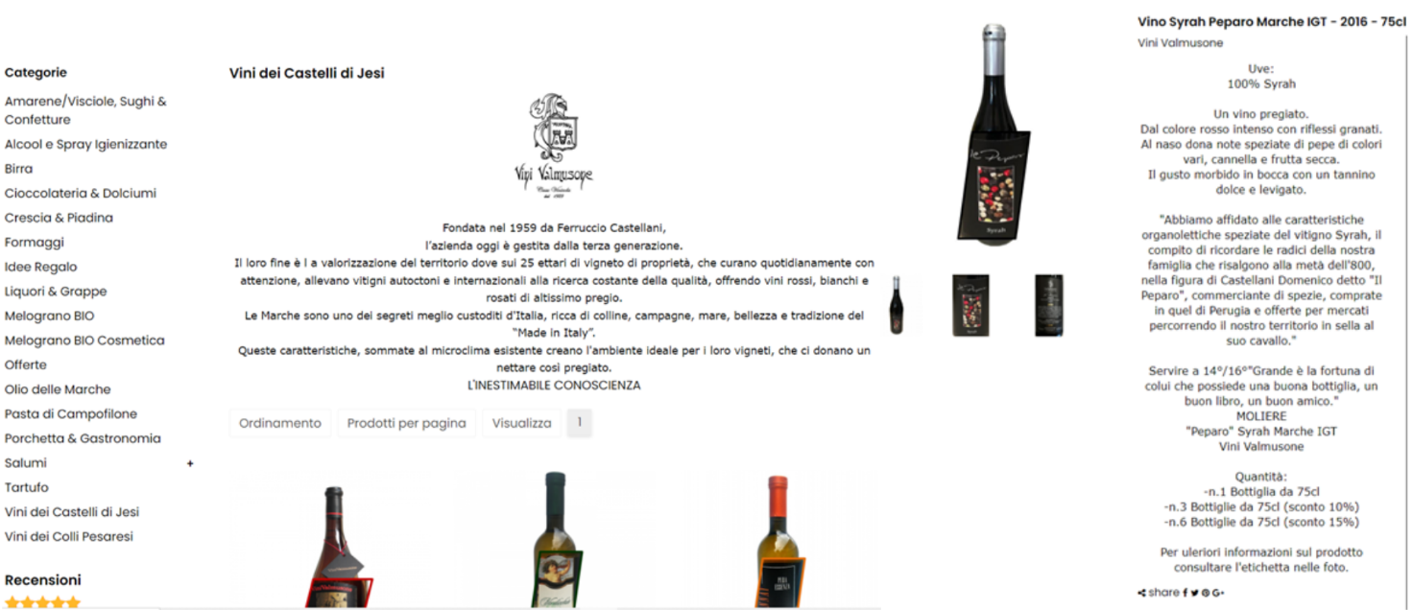

Fig. 7. Omnichannel partner involvement in the CHM process. (Source: our elaboration from Riviezzo et al. 2021).
(p.14)

