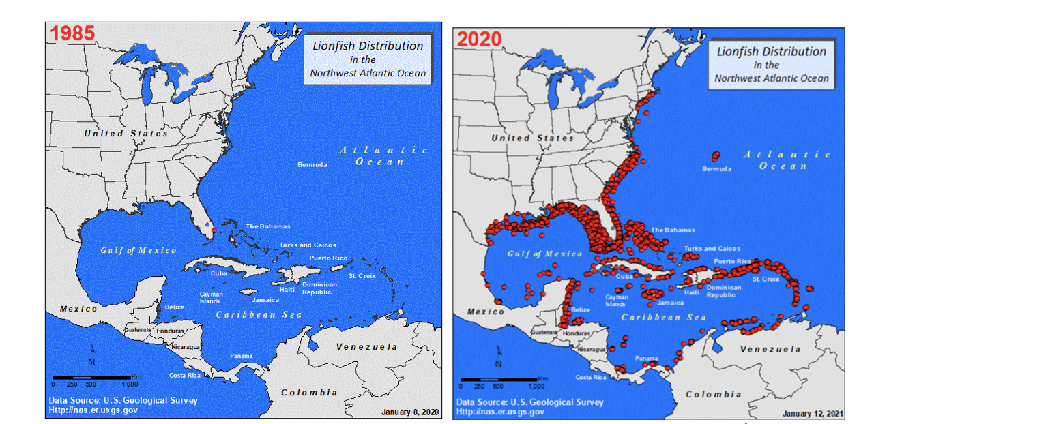
Figure 1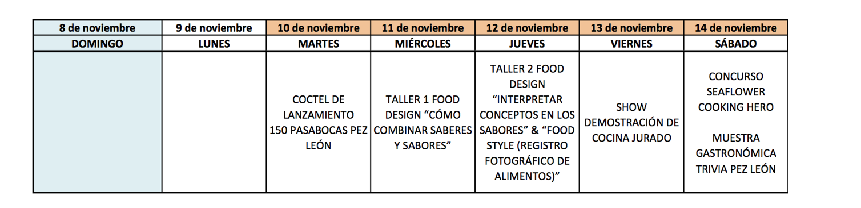
Figure 2

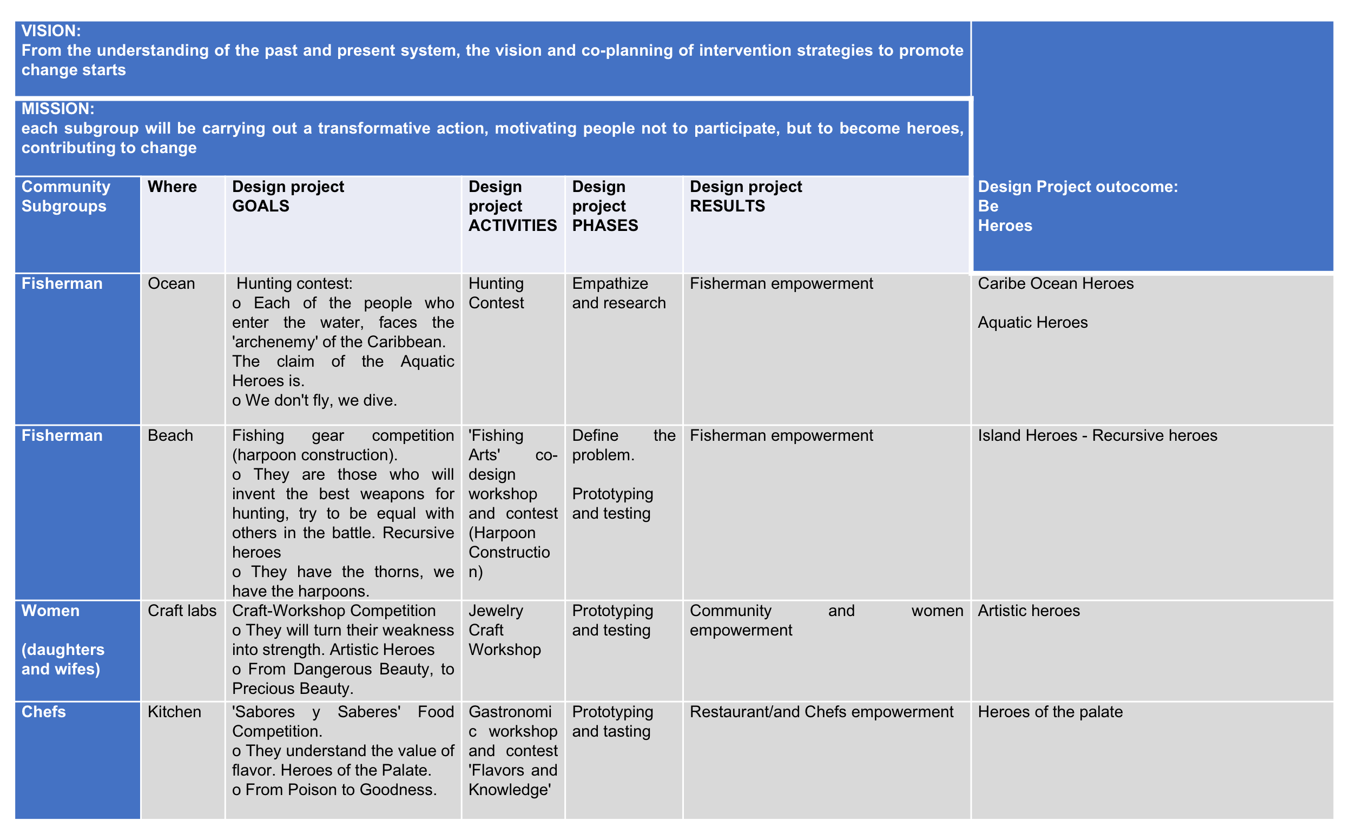
Figure 3

Appendix
Figure 1 Source/Usage: public domain. Reported lionfish sightings. Map ( 1985-2020) Map created by US Geological Survey Nonindigenous Aquatic Species Database (https://www.usgs.gov/centers/wetland-and-aquatic-research-center/science/lionfish-distribution-geographic-spread-biology)
Figure 2. This is the tentative program that is invited to the professors and students, as part of the official invitation ( Source: provided by prof. Juan Jose Arango)
Figure 3. Heroes matrix (Source: created by the authors)

