FIGURE 1
Paragraph:

Porters’ Five Forces framework
In 1979 Michael Porter developed a framework for responding strategically to competition in an industry, based on the analysis of four forces - new entrants, suppliers, customers, and substitutes - in addition to existing competitors. More recently, the author further developed the framework: in his understanding, these competitive forces mean revealing the underlying causes or roots of an industry’s current competition, and can serve in the creation of a framework useful for formulating a strategy for anticipating and influencing competition over time, as presented in Figure 1.
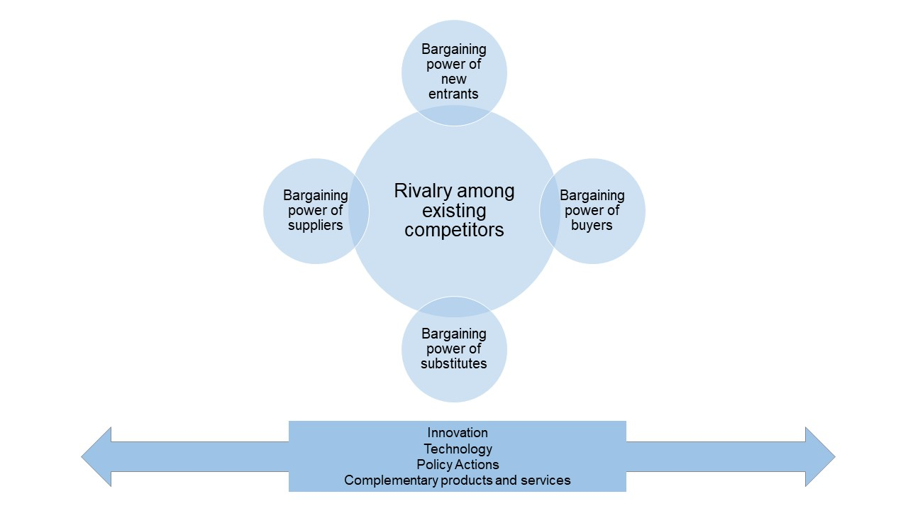
Fig. 1. The Five Forces and factors that shape industry competition (Source: Porter 2008)
This framework has been applied to several studies analysing the tourism industry.
The Porters’ forces are the following:
[…]

FIGURE 2
Paragraph:

Factors influencing Porter’s forces
[…]
To summarise, Figure 2 shows the application of Porter’s framework to the Educational Tourism Industry in the Marche Region, showing which forces interact in the industry, which changes in one force could influence others and which factors have a potential impact on the forces.
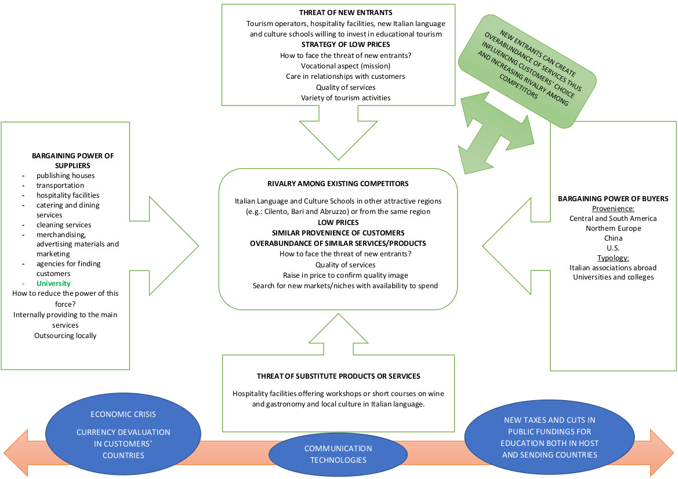
Fig. 2. Porter’s framework applied to educational tourism industry in Marche Region

Conclusions
[…]

Porter 1979, 1980.
Porter 2008.
Andriotis 2004, Dobrivojević 2013, Nurlansa, Jati 2016; Iturralde, Guerrero 2018.

