Annex A

Final Database of EU Policy for Cultural Heritage, Regional Policy and EU Digital Single Market Policy

EU Cultural Policy Framework | European Commission communication “Towards an integrated approach to cultural heritage for Europe” (2014)
 | Work Plan for Culture (2015-2018)
 | New Agenda for Culture (2018)
 | Work Plan for Culture (2019-2022)
 | European Framework for Action on Cultural Heritage (2019)
 | Work Plan for Culture (2023-2026)
EU Regional Policy framework | European Regional Development Fund (2014-2020)
 | European Regional Development Fund (2021-2027)
EU Programmes and initiatives for Culture-led regional and Urban development | Interreg (2014-2020)
 | Interreg (2021-2027)
 | Recovery and Resilience Facility (2021-2026)
 | Recovery and Resilience Fund Culture and Creativity Scoreboard (2021-2026)
 | Urban Agenda for the EU- Partnership on Culture/Cultural Heritage
 | Urban Innovative Actions
EU programmes and initiatives for Cultural Heritage’s digital transformation | Horizon 2020 Work programme (2018-2020)
 | Horizon Europe Strategic Plan (2021-2024)
 | Horizon Europe work programme (2021-2022)
 | Horizon Europe work programme (2023-2024)
 | Commission Recommendation on a common European data space for cultural heritage (2021)
 | Digital Europe Programme (2021-2027)
 | Digital Europe work programme (2021-2022)
 | Digital Europe work programme (2023-2024)
Annex A. Final Database of EU Policy, programmes and initiatives taken into consideration for the analysis

Annex B
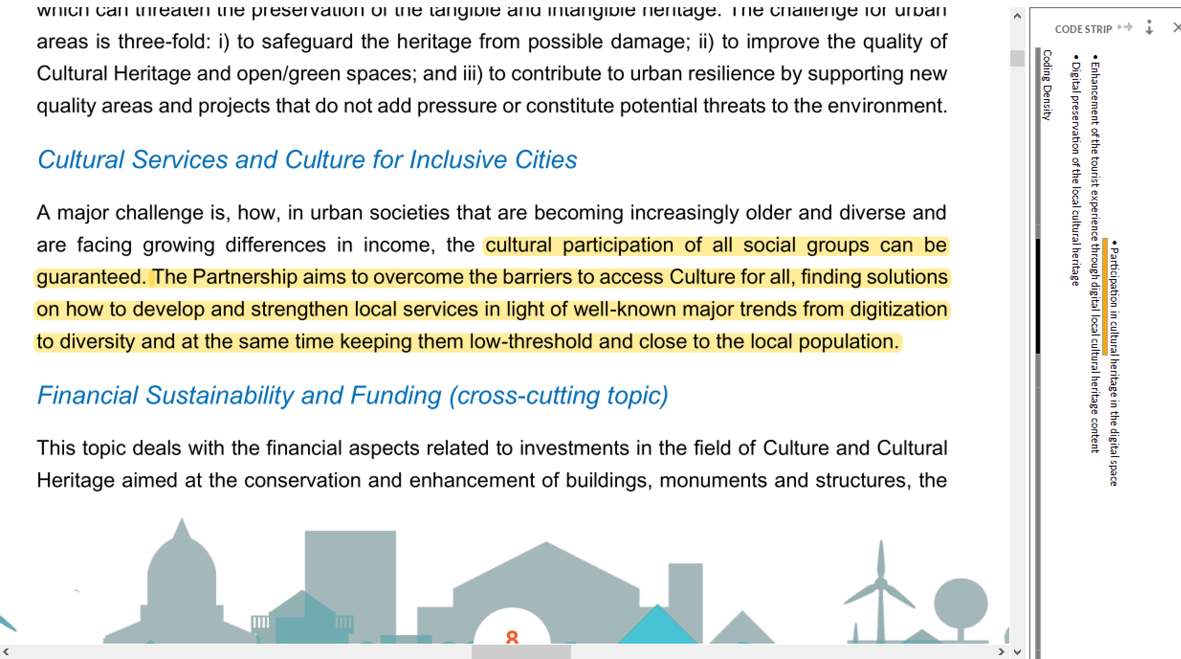
Annex B. Example of the Nvivo 14 software interface with the coding stripes on the side.

