Images
Figure 1
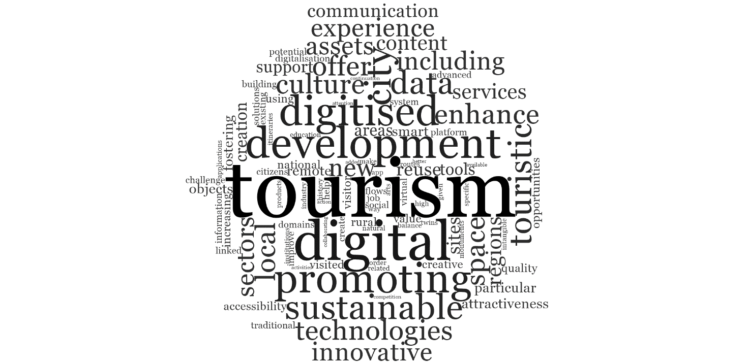
Figure 1 Word Cloud of the Most Frequent Words in policy texts mentioning the importance of the enhancement of the tourist experience through digital local cultural heritage content

Figure 2
Figure 2 Word Cloud of the Most Frequent Words in policy texts mentioning the importance of the Digital preservation of the local cultural heritage
Figure 3
Figure 3 Word Cloud of the Most Frequent Words in policy texts mentioning the importance of the participation in cultural heritage in the digital space

Figure 4
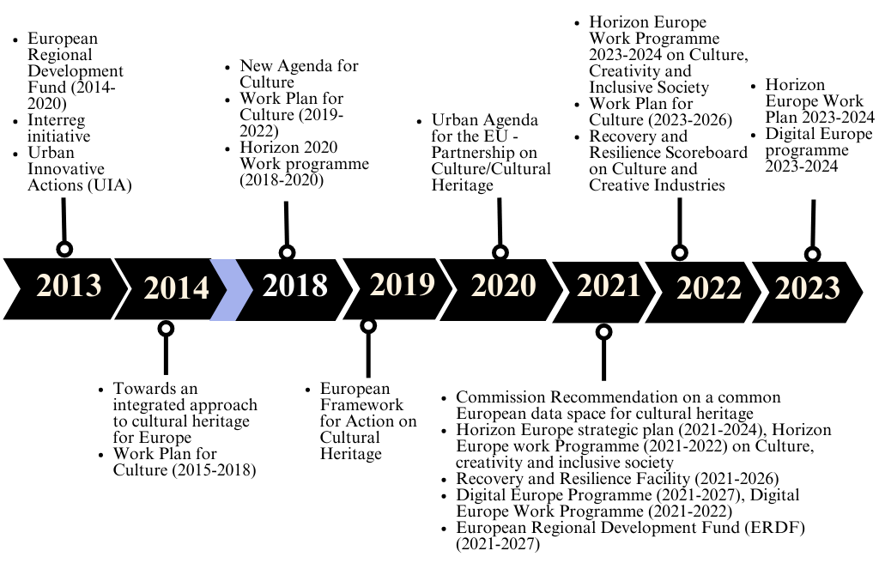
Figure 4 Timeline with documents published by the European Union considering the application of digital technologies to cultural heritage for local development

