Immagini e tabelle

Table 1. A theoretical taxonomy of the components of territorial capital

Private fixed capital stock

Pecuniary externalities
(hard)

Toll goods (excludab.) c

Private relational know-how in:

- firms’ external linkages
- transfer of R&D results
- university spin-offs
i

Human capital:
- entrepreneurship
- creativity
- private know-how

Pecuniary externalities
(soft) f
High rivalry

(private
goods)

Rivalry
(impure
public
goods)
Low rivalry
(public
goods)
(club
goods)
Materiality
Tangible goods
(hard)

Mixed goods
(hard + soft)
Intangible goods
(soft)
Cooperation networks:
- strategic alliances in R&D and knowledge
- p/p partnerships in large develop. schemes
Quality of institutions
Governance on land and cultural resources h

Proprietary networks

Collective goods (commons):
- landscape (rur./urb.)
- cultural heritage
(“ensembles”: historical centres) b

Relational capital (associationism):
- cooperation capability
- collective action capability
- collective competencies
- identity e

E

Resources:
- natural - cultural (punctual)

Social overhead
capital:
- infrastructure
a
Accessib./Connectivity
Agglomeration and district economies

Local receptivity- enhancing conditions
Agencies for R&D transfer / transcoding g
Social capital (civicness):
- institutions
- behavioural
models, values
- trust, reciprocity
- reputation
d

Source: adapted from Camagni (2019).

Table 2 – Potential areas of cultural heritage impact
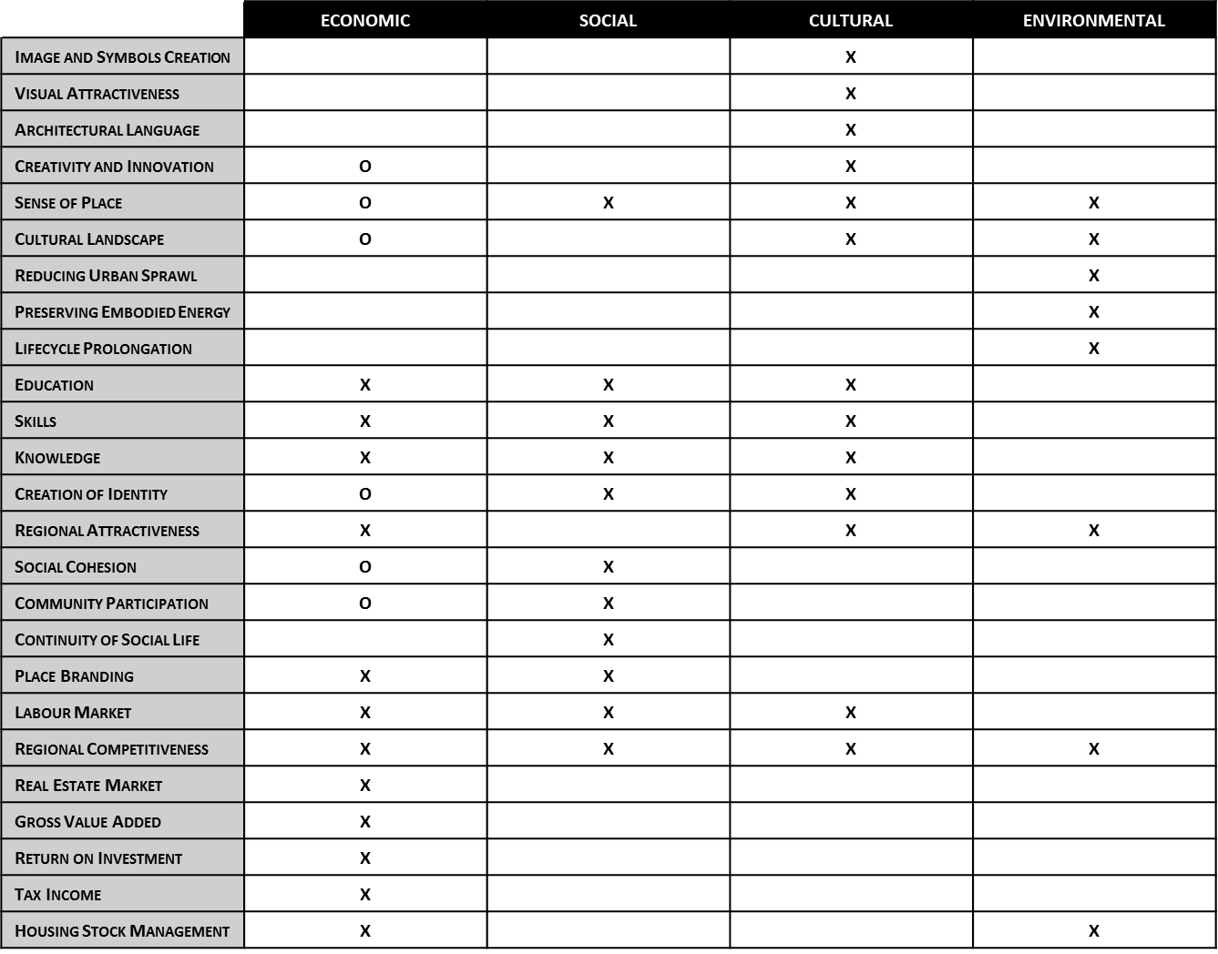
Source: Authors’ elaboration on CHCfE (2015). “X” areas introduced by CHCfE, “O” areas added by these authors.
Figure 1 – A visual representation of possible combinations of creativity endowments in a local area
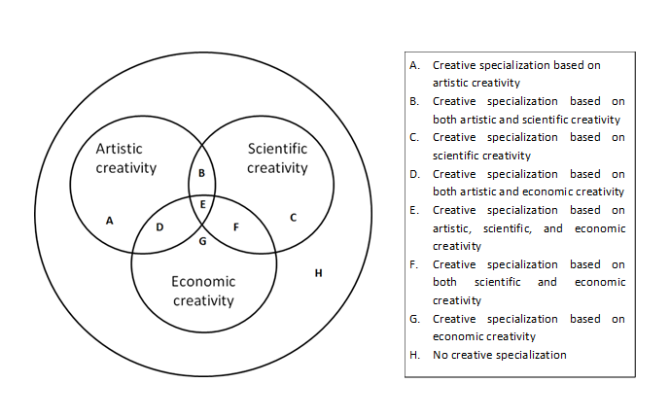
Source: Cerisola (2018a).

Figure 2 – Patterns of creative specialization: distribution of Italian provinces in 2011
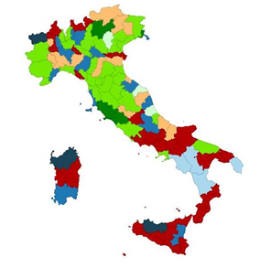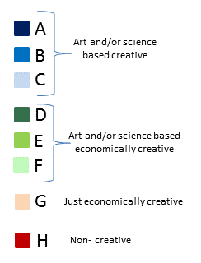
Source: Cerisola (2018b)

Figure 3 – A visual representation of the proposed taxonomy of modes of expression of territorial identity(ies)
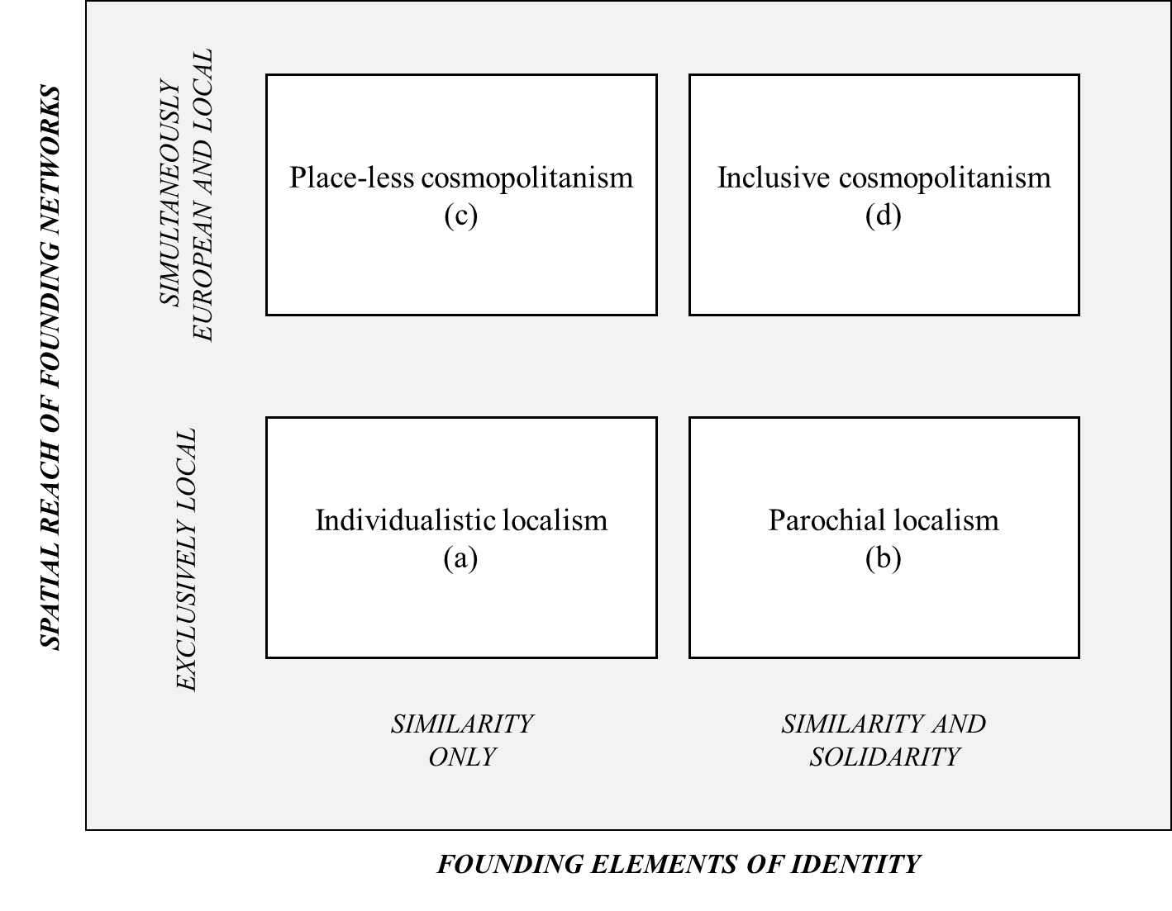
Source: authors’ elaboration.

Figure 4 – The four modes of expression of territorial identity(ies) in European regions in 2017-2018
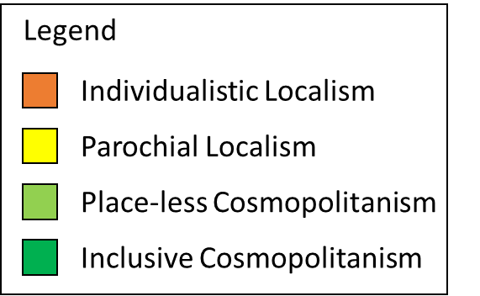
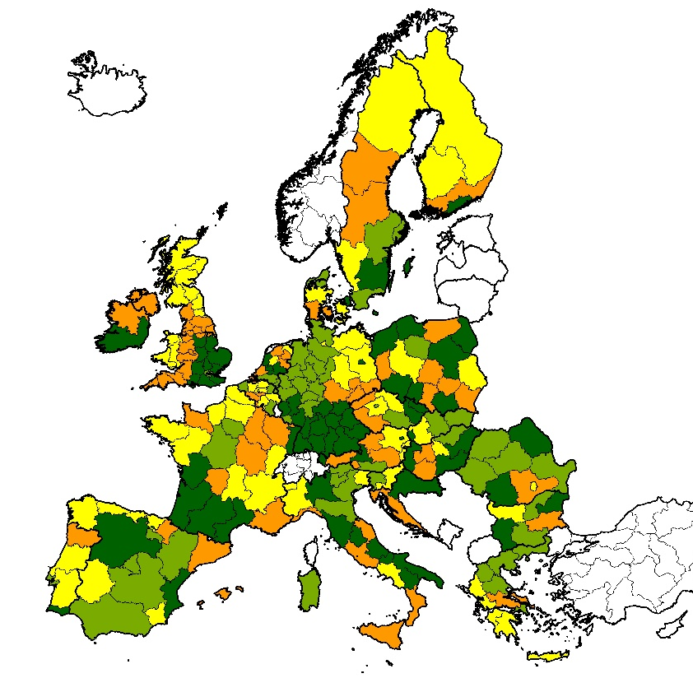
Source: authors’ elaboration.
Figure A1 – From cultural heritage to development through creativity: summary
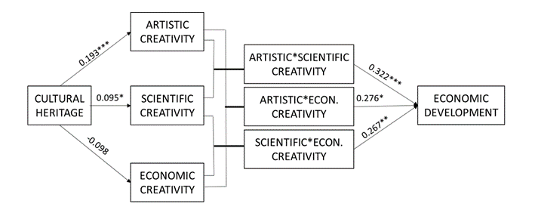
Source: Cerisola (2019b).
Standardized coefficients. Robust standard errors. Significance levels * 10%, ** 5%. *** 1%.
Annex 2: Cultural heritage, territorial identity and socio-economic development – Empirical evidence
 | (1) | (2) | (3) | (4)
VARIABLES
GDP per capita | -0.644* | -0.651* | -0.792** | -0.787**
 | (0.358) | (0.358) | (0.374) | (0.378)
Multimodal Accessibility per capita | 0.241 | 0.247 | 0.217 | 0.200
 | (0.183) | (0.183) | (0.183) | (0.188)
Employment (level) | 0.019 | 0.023 | 0.033** | 0.033**
 | (0.015) | (0.015) | (0.014) | (0.014)
Education | 5.869** | 5.525** | 5.864** | 5.477*
 | (2.473) | (2.453) | (2.660) | (2.806)
Population Density | -0.013 | -0.020 | -0.014 | -0.016
 | (0.014) | (0.013) | (0.015) | (0.016)
Manufacturing (Share active population) | -7.219 | 27.349 | 169.437 | 155.945
 | (240.606) | (245.078) | (252.833) | (257.465)
Innovation | -0.067 | -0.062 | 0.015 | 0.018
 | (0.071) | (0.072) | (0.079) | (0.081)
Number of tourist arrivals per capita |  |  | 0.001** | 0.001**
 |  |  | (0.001) | (0.001)
Cultural Heritage (Monuments) |  | 2.932** | 1.696 | -2.001
 |  | (1.258) | (1.356) | (2.520)
2._Parochial Localism |  |  | -0.001 | -0.001
 |  |  | (0.001) | (0.002)
3._Place-less Cosmopolitanism |  |  | -0.001 | -0.001
 |  |  | (0.002) | (0.002)
4._Inclusive Cosmopolitanism |  |  | 0.001 | -0.001
 |  |  | (0.002) | (0.002)
2._Parochial Localism*Cultural Heritage |  |  |  | 6.441
 |  |  |  | (5.522)
3._Place-less Cosmopolitanism*Cultural Heritage |  |  |  | 4.196*
 |  |  |  | (2.857)
4._Inclusive Cosmopolitanism*Cultural Heritage |  |  |  | 12.809*
 |  |  |  | (6.562)
Regional Fixed Effects (NUTS1) | YES | YES | YES | YES
Time Fixed Effects | YES | YES | YES | YES
Constant | 0.023*** | 0.024*** | 0.022*** | 0.024***
 | (0.007) | (0.007) | (0.007) | (0.007)
Observations | 786 | 786 | 746 | 746
Number of nuts2_code | 262 | 262 | 249 | 249
Table A2. Empirical Results
Robust standard errors in parentheses
*** p<0.01, ** p<0.05, * p<0.15
The dependent variable is the GDP per capita at constant prices growth rate in three distinct time spans: 2014-2016; 2015-2017; 2016-2018
Cultural heritage is here measured as the regional number of monuments per square kilometers standardized by country. The source of the number of monuments is the ESPON project 1.3.3: “The role and spatial effects of cultural heritage and identity (2004-2006)”.

