Graphs
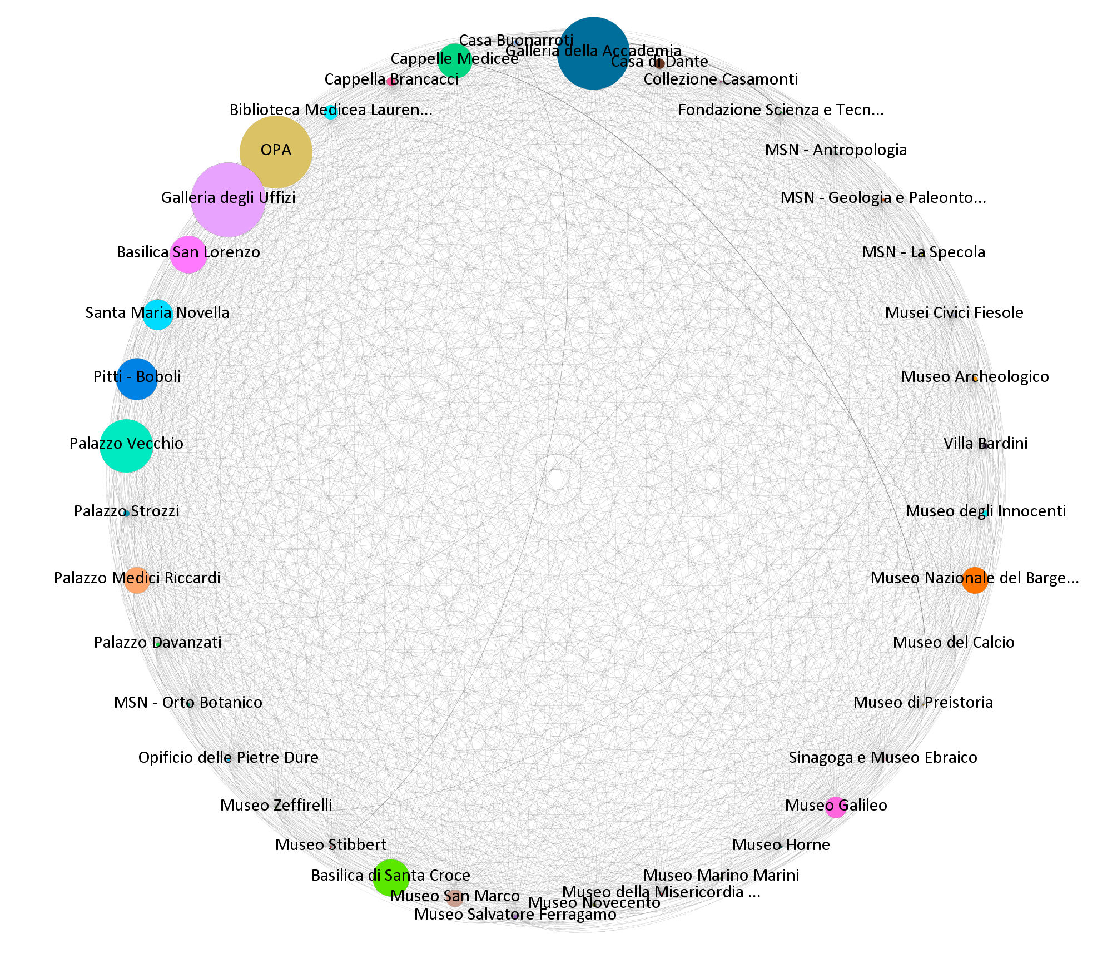
Graph 1. The co-visits museum networks (Source: our elaborations).

Graph 2a: Indegree | Graph 2b: Outdegree
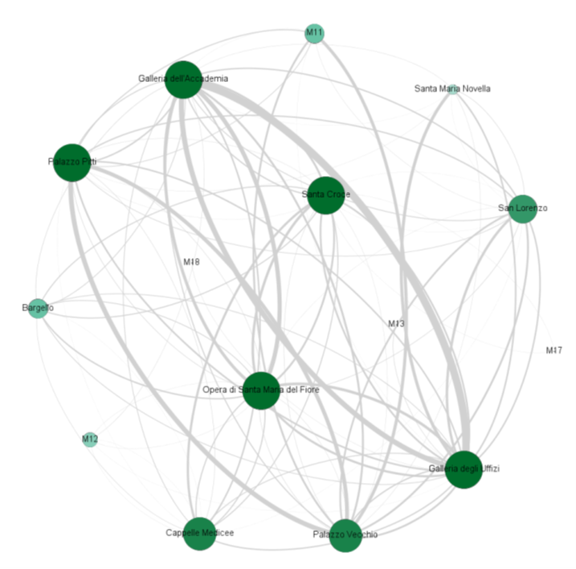 | 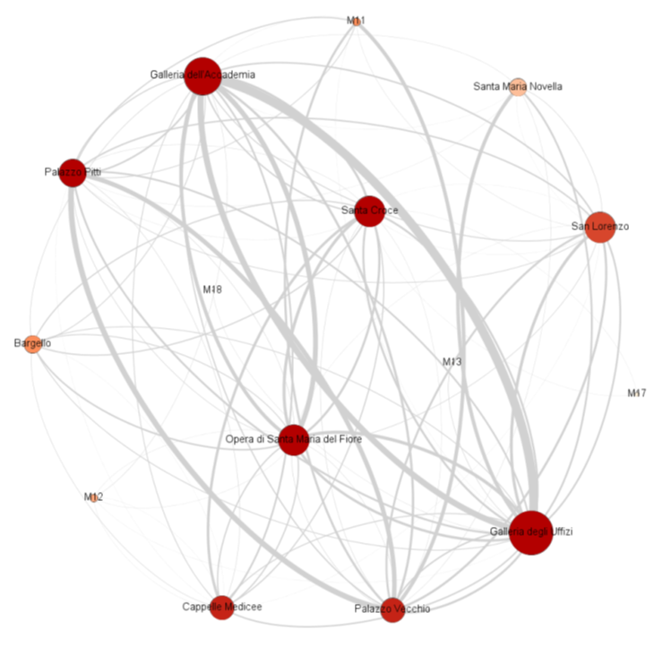
Graph 2. The network of co-visitors (at least 1000 co-visits): in/out degree (Source: our elaborations).

Graph 3a: The ego-netwok of Bargello | Graph 3b: The ego-netwok of Uffizi
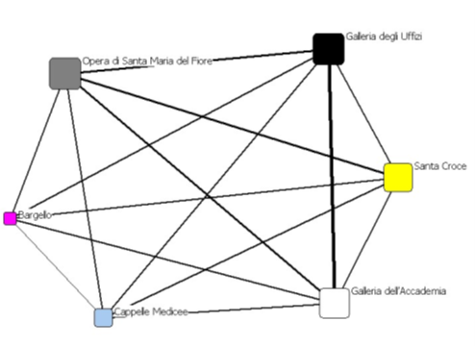 | 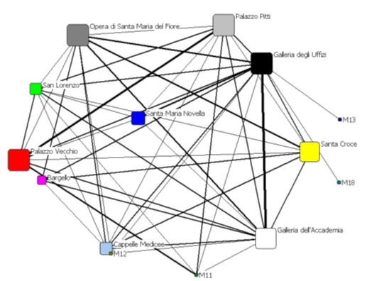
Graph 3c: The ego-netwok of SMN | Graph 3d: The ego-netwok of Palazzo Pitti
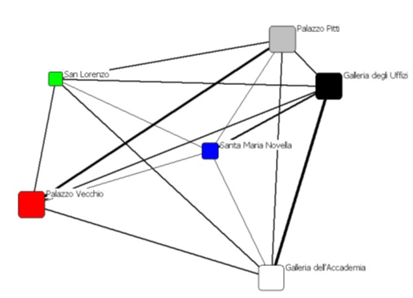 | 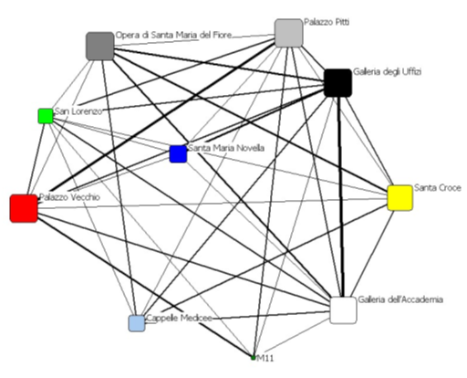
Graph 3. Some ego-networks (Source: our elaborations).

