Figures



Fig. 1. A comparison among Firenze Cards sold and tourism nights spent in 2018 (Source: our elaboration on Bacci *et al.* 2019 and Florence Metropolitan. City).

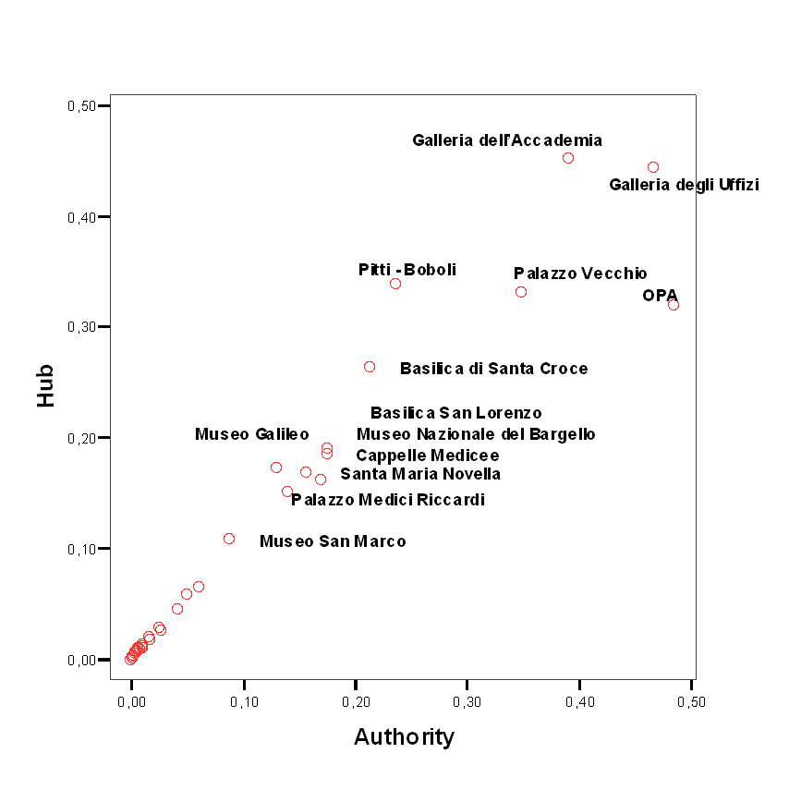

Fig. 2. Authority and hub scores of museums (Source: our elaboration).

|  |  |
| --- | --- |
|  |  |

Fig. 3. The “geographical” ego-network of Galleria degli Uffizi (Source: our elaboration).