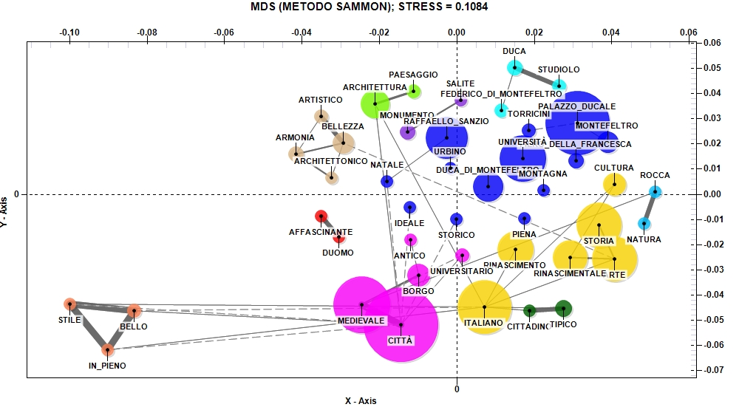
Fig. 2. Associations with Urbino (Source: our elaboration)

