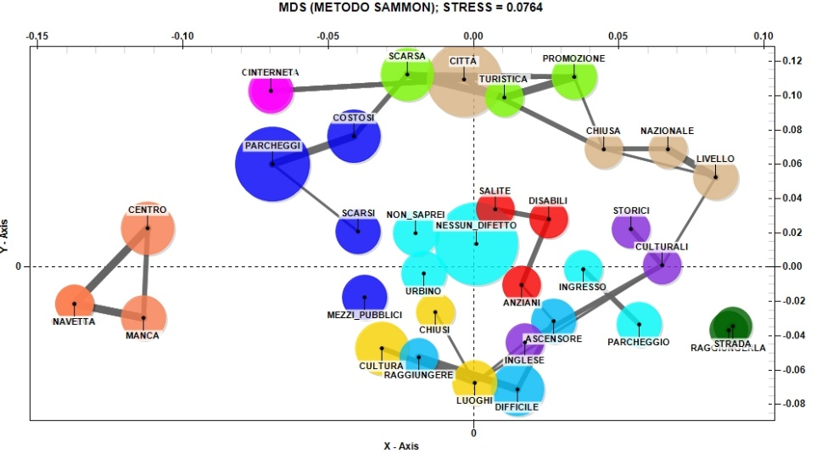

Fig. 14. The relationship between the main negative aspects of visiting Urbino and the low evaluation of friendliness and cordiality of residents (Source: our elaboration)

