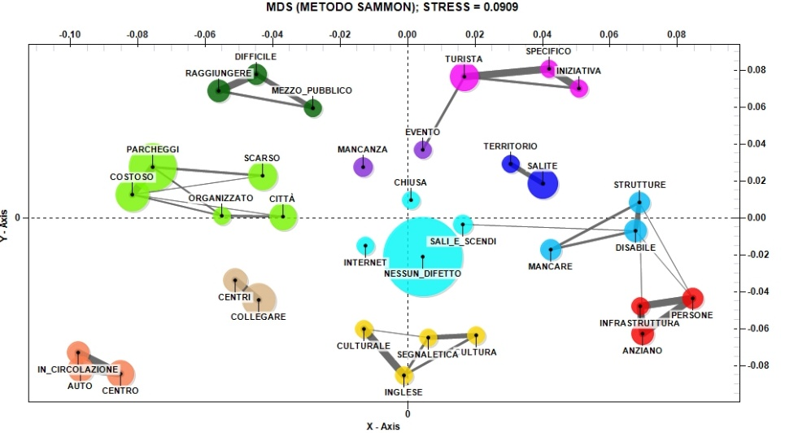
Fig. 13. The relationship between the main negative aspects of visiting Urbino and the high evaluation of friendliness and cordiality of residents (Source: our elaboration)

