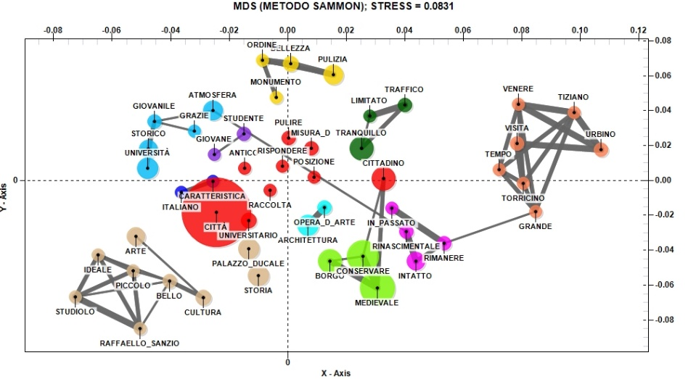
Fig. 12. The relationship between the main positive aspects of visiting Urbino and the low evaluation of the friendliness and cordiality of residents (Source: our elaboration)

