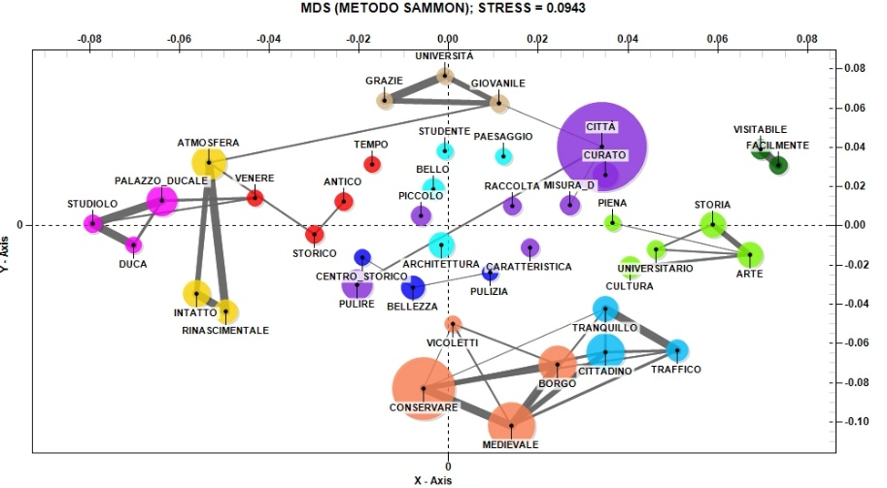

Fig. 11. The relationship between the main positive aspects of visiting Urbino and the high evaluation of the friendliness and cordiality of residents (Source: our elaboration)

