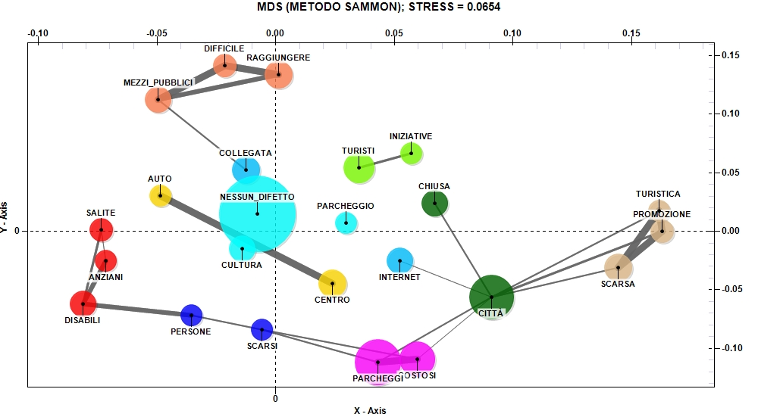
Fig. 10. The relationship between the main negative aspects of visiting Urbino and the low evaluation of restaurant services (Source: our elaboration)

