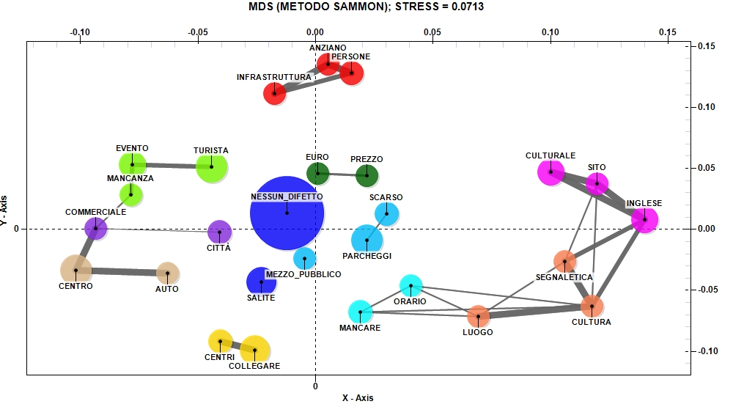
Fig. 9. The relationship between the main negative aspects of visiting Urbino and the high evaluation of restaurant services (Source: our elaboration)

