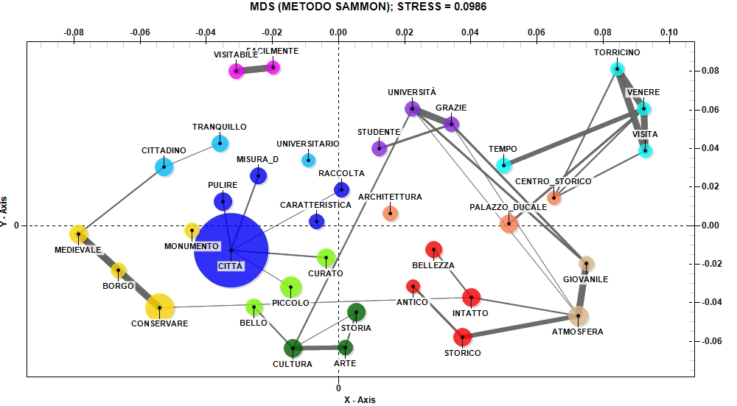
Fig. 8. The relationship between the main positive aspects of visiting Urbino and the low evaluation of restaurant services (Source: our elaboration)

