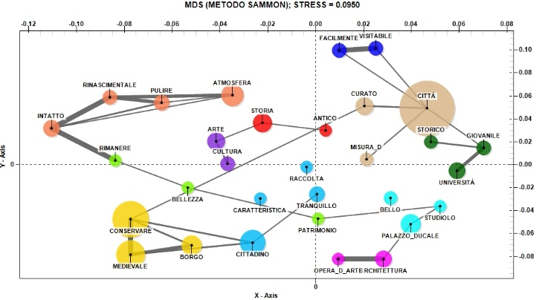
Fig. 7. The relationship between the main positive aspects of visiting Urbino and the high evaluation of restaurant services (Source: our elaboration)

