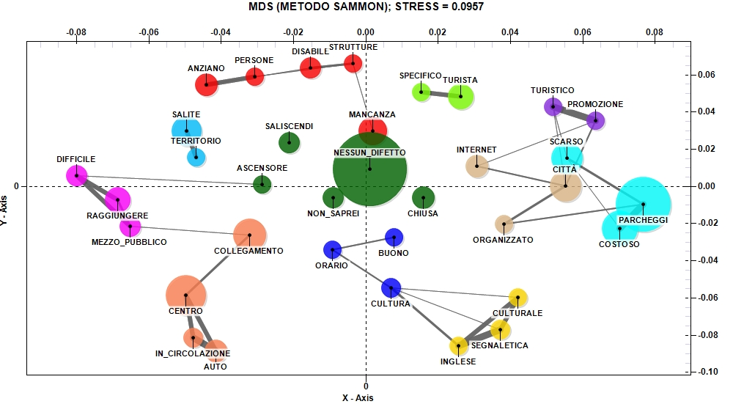
Fig. 4. Main negative aspects of Urbino visit (Source: our elaboration)

