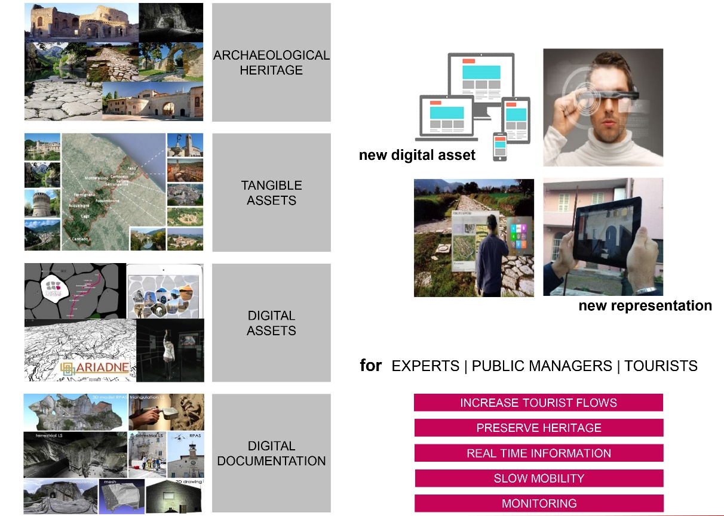
Fig. 1. The Flaminia Nextone DCE project: graphical abstract
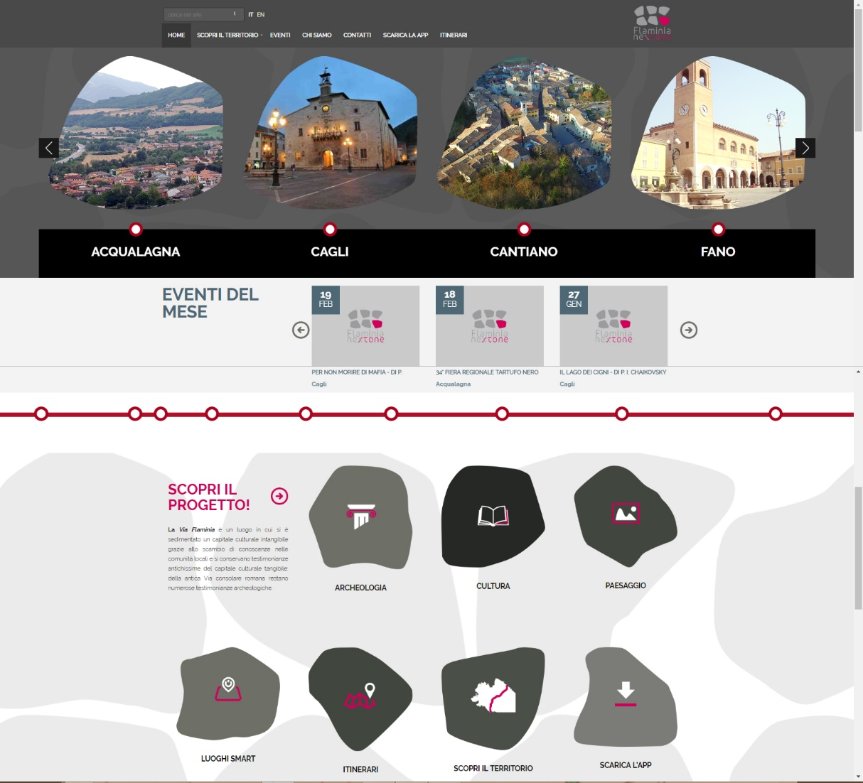
Fig. 2. The Home page of the web site
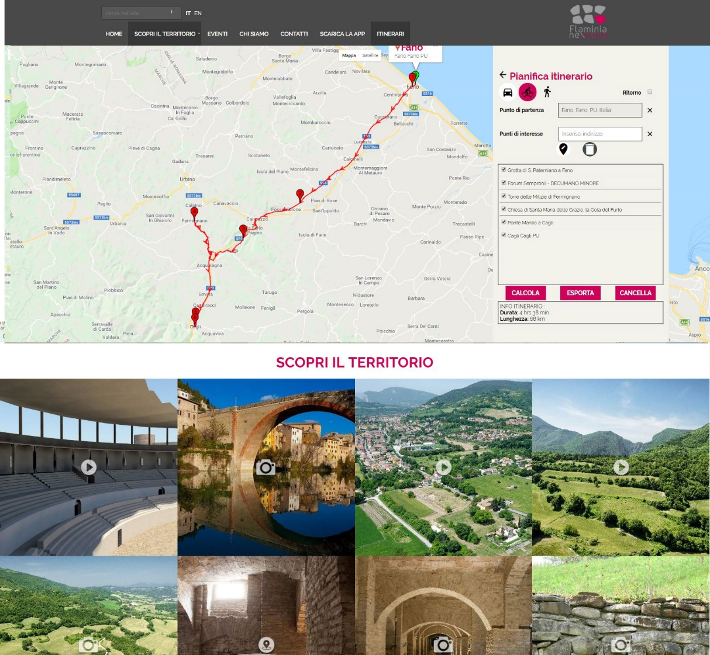
Fig. 3. Two section of the web site: on top, “itineraries”; below, “destinations”
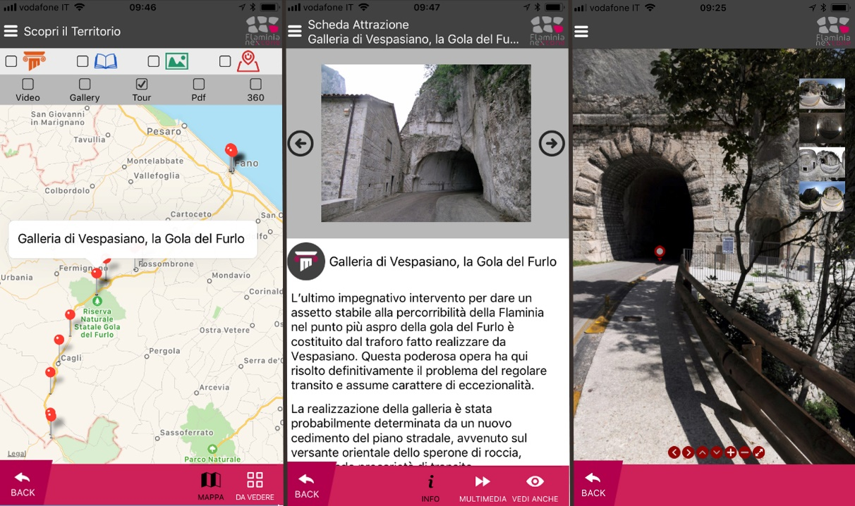
Fig. 4.The app Flaminia Nextone: a POI with linked multimedia; on the right, a full dome view.

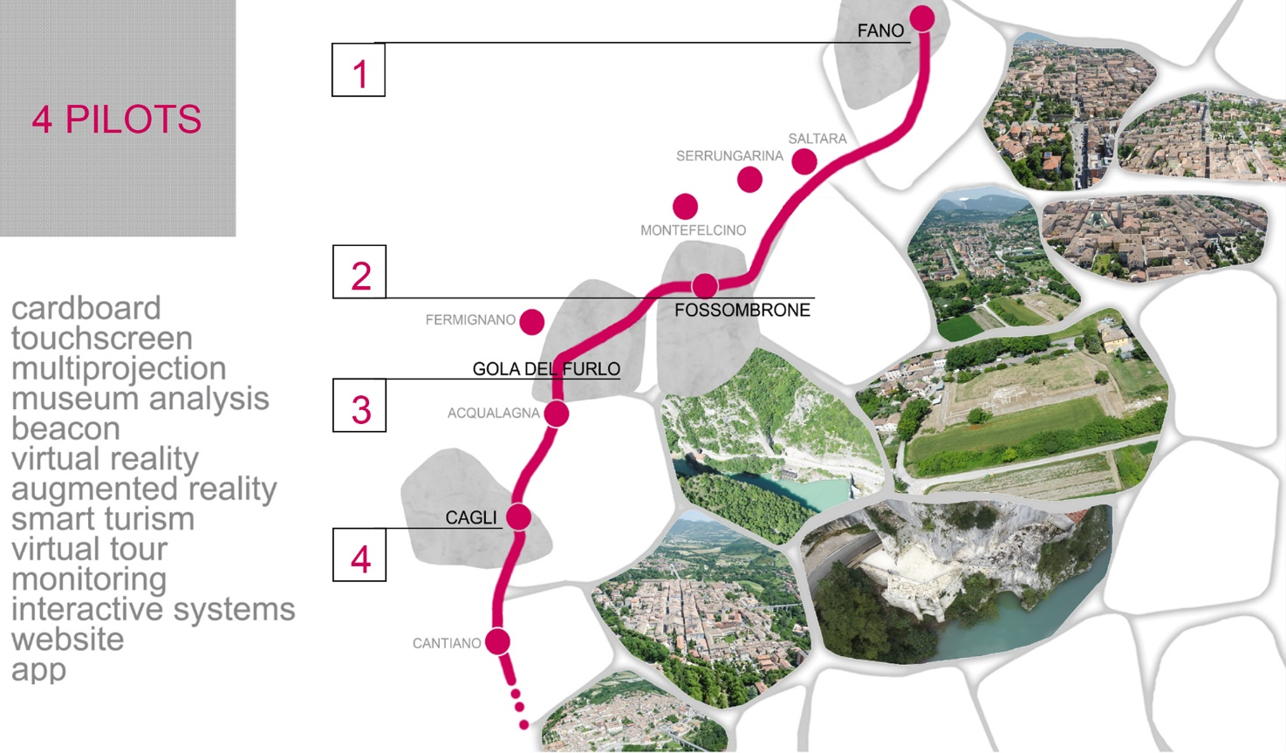
Fig. 5. Keywords and localization of the 4 pilots.
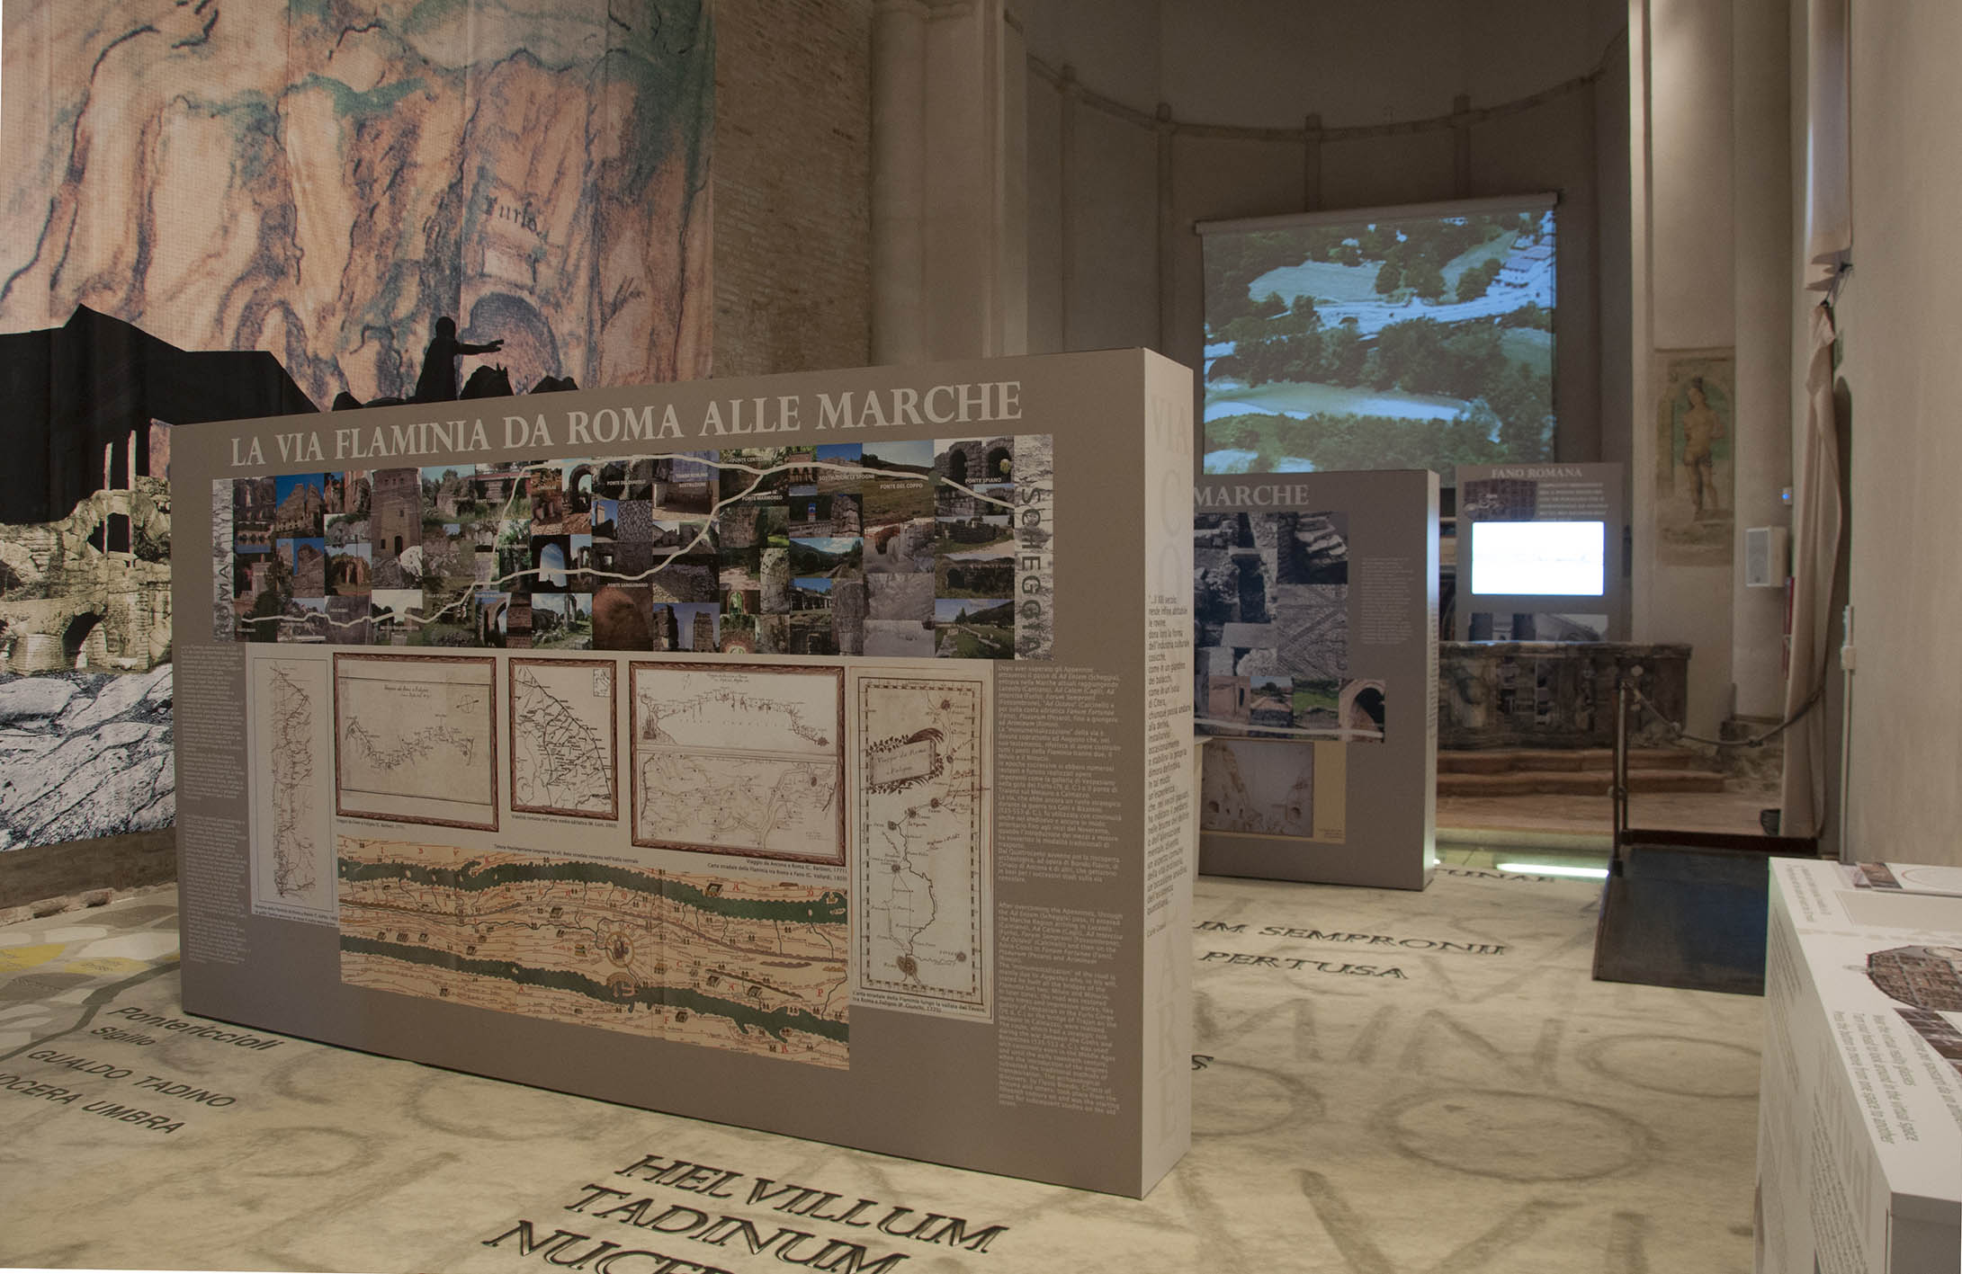
Fig. 6. A picture of the Museum of Via Flaminia at Fano
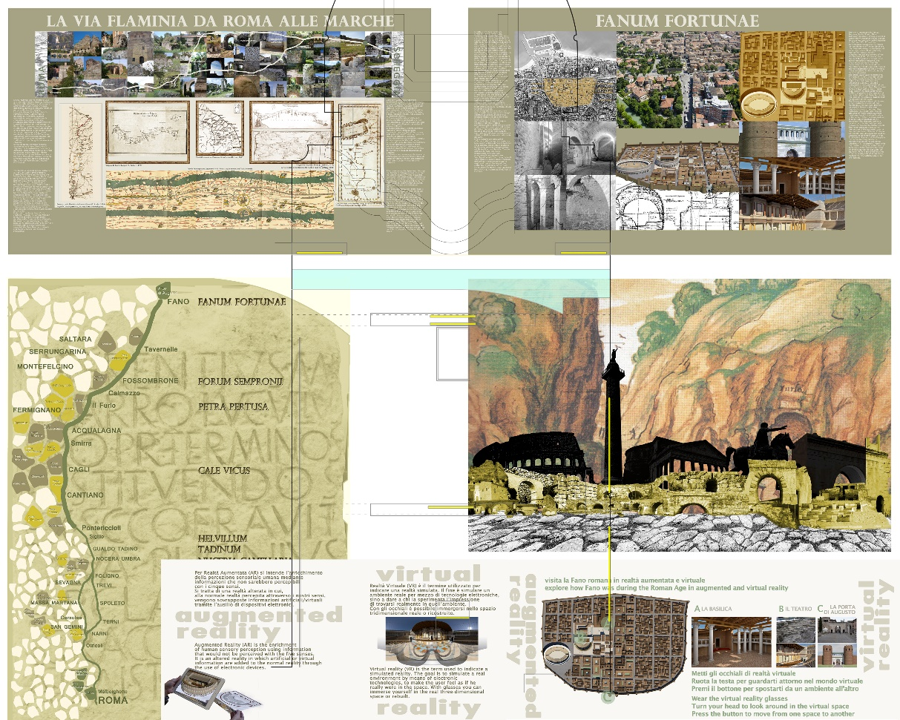
Fig. 7. Main contents of the Musem
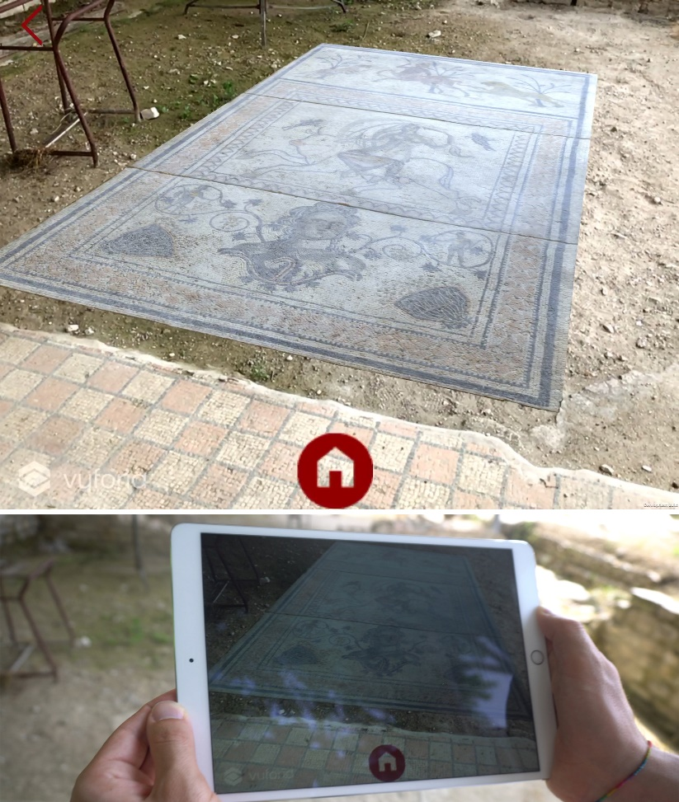
Fig. 8. The Forum Sempronii AR App: on top, screenshot of the App during the superimposition of the mosaic; below, a picture of user in the Domus of Europa using the App
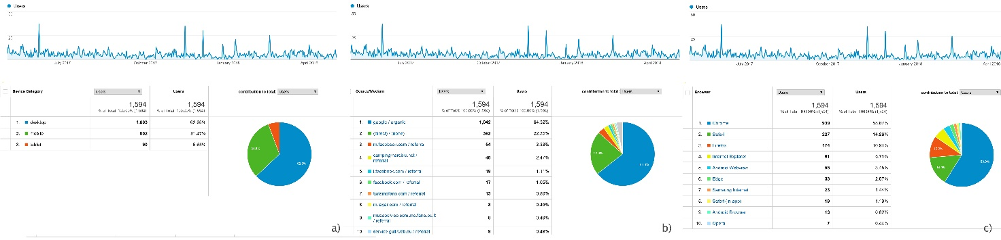Fig. 9. The analitycs about access to web platform Nextone: a) device category, b) medium, c) browser
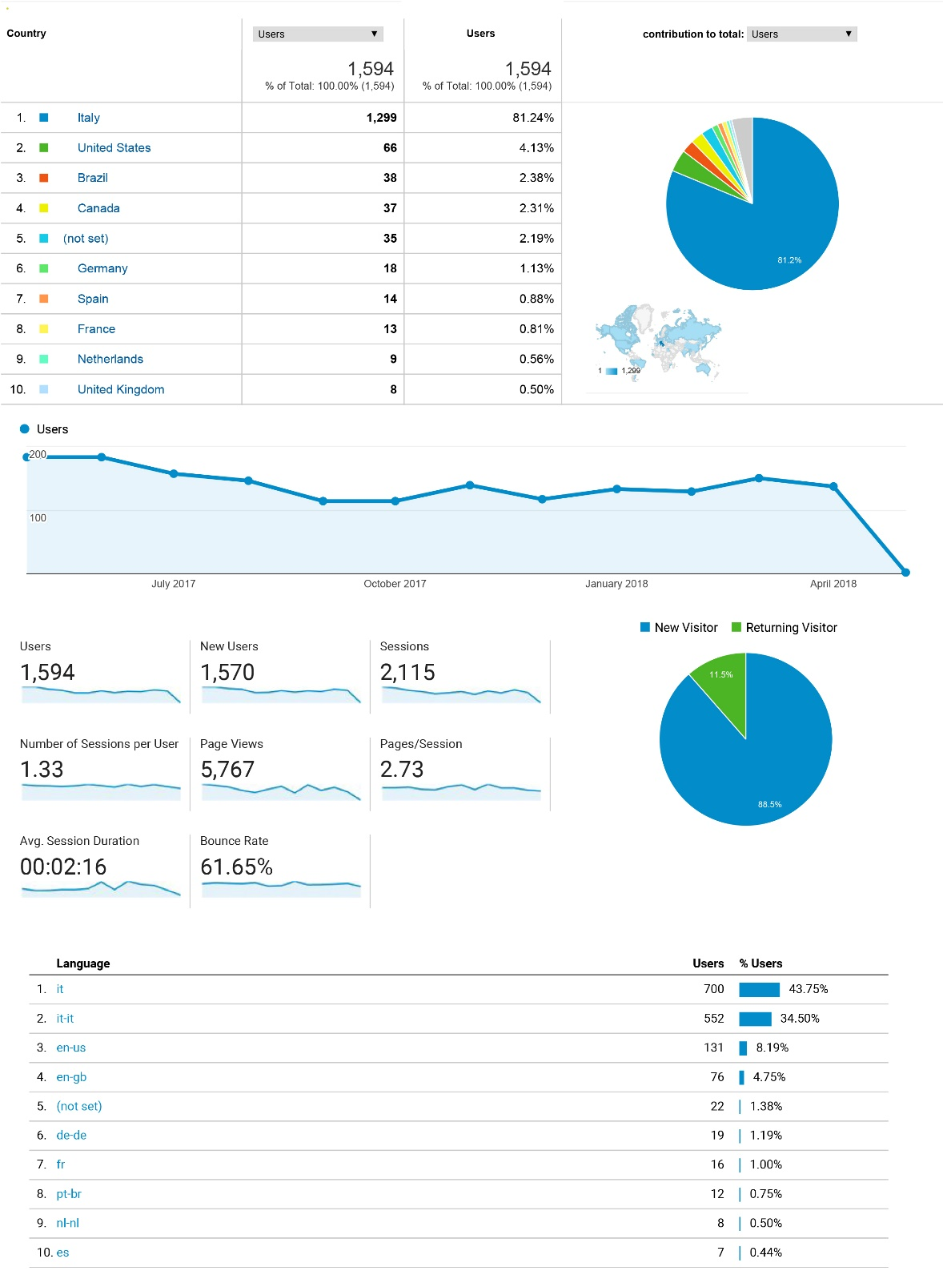
Fig. 10. The analitycs about access to web platform Nextone: on top, country; below, language.

